ST CLEER PRIMARY ACADEMY

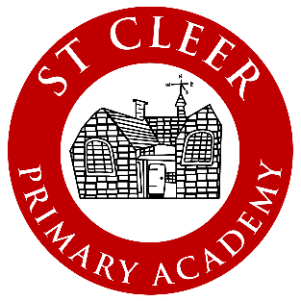

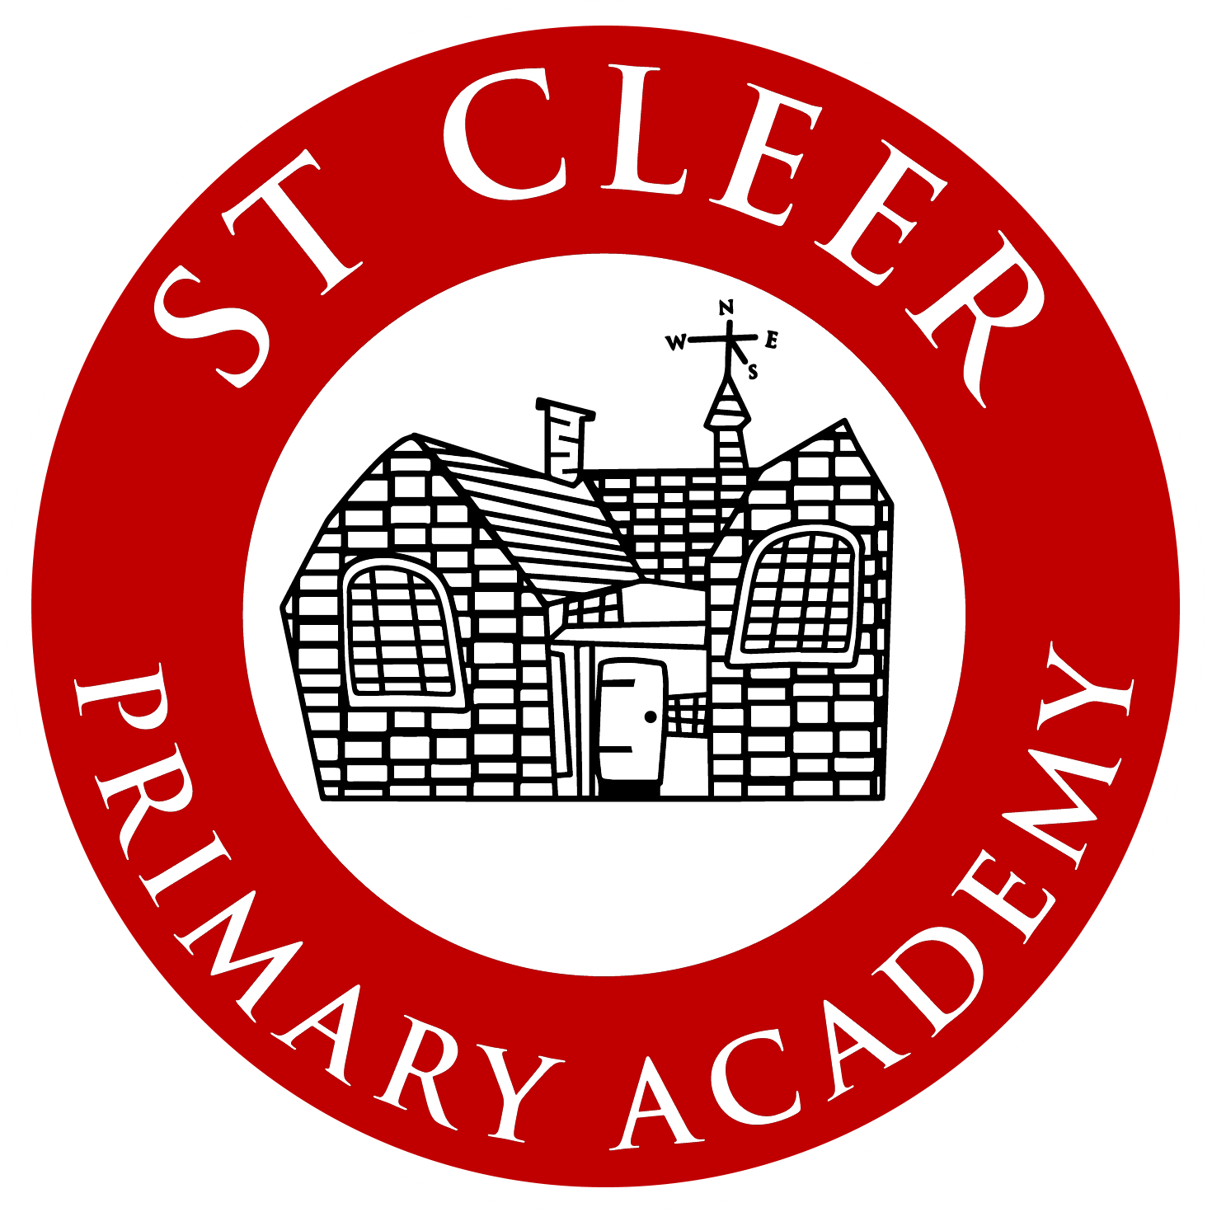

Any parent or carer with a child currently attending the school is eligible to nominate themselves to stand in an election to become a Parent Governor at the school.

If you wish to be considered, then please complete this form and return to the school office no later than 1pm on February 26th 2021.

Surname
First name
Address
Postcode
Preferred contact number
Email

A school representative will be in touch with you following your application and inform you of relevant next steps.

For a successfully appointed governor, this will involve:
- a DBS check
- completion of a pecuniary interests’ form
- a pen portrait for our school website
- a skills audit.

Supporting information - Why I want to be a Parent/Community Governor

Please tell us something about yourself and why you would like to be a Parent/Community Governor at St Cleer Primary Academy.

This statement will be shared with all parents if the school needs to hold a secret ballot.
Name:
Why I want to be a Parent/Community Governor at St Cleer Primary Academy

