4/5P WORK TO DO AT HOME
In the event that the children have to do school work at home, here are some activities we would like you to do:
- Refer to our school website regularly: Miss Parris will update it.
- Read as often as you can.
- Write book reviews of the books you have read.
- Use Mathletics to carry out maths tasks, especially work on DECIMALS.
- Learn your x tables – all or as many of them as you can so that you know them quickly and randomly. www.MathsFrame is very good for practicing x tables.
- Practise your handwriting.
- You could keep a diary.
- Learn your spellings from the Year 3 / 4 or 5/6 lists.
- Write your story based around the them of MAGIC using the ideas you have already planned in class.
- Our Learning Adventure next term is linked closely to Geography and will be focusing on the USA. Carry out some research on the USA – you could do your own mini project.
- Do some observational drawings – remember to shade.
- Think of your own writing tasks that you would like to do.
- Do some exercise each day. GoNoodle and Just Dance can be accessed on the internet, but check with your parents first.

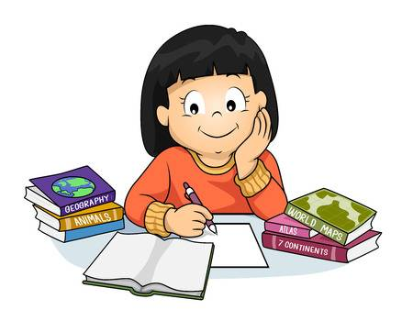

Take care of yourselves. Work hard.
Miss Parris, Mrs Pritchard and Mrs Goldsmith.

