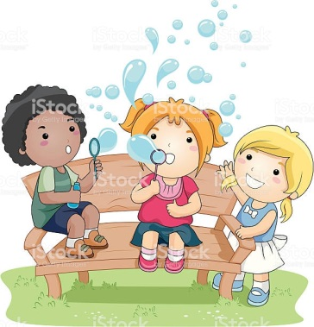
Understanding the World
- Look for signs of spring in the garden.
- Read information books on frogs and chicks
- Hunt for bugs in the garden
- Use Nature Detectives for lots of exciting activities to do at home: https://naturedetectives.woodlandtrust.org.uk/naturedetectives/
- Planting seeds such as cress – and watching them grow
- Look at science experiments for Early Years https://www.firstdiscoverers.co.uk/early-years-science-activities-eyfs/
- Observe the weather each day and make a weather chart
- Make a family tree – who is in your family
- Freeze small toys in ice – and work out how to get them out of the ice
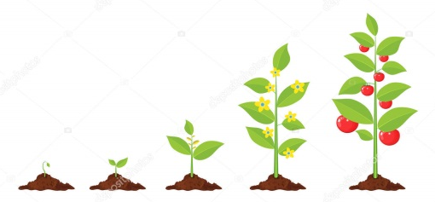
- Make a rainbow of skittles sweets around the edge of a small plate – add warm water and watch a rainbow appear.
Expressive Art and Design
- Dancing to music – use scarves
- Sing familiar songs and make up your own words to nursery rhyme tunes
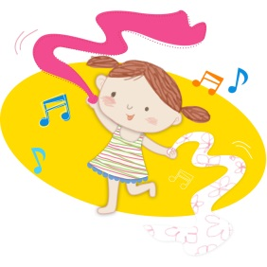
- Make shakers with pasta or rice in pots
- Make your own paint with shaving foam or coloured ice
- Make props for your favourite story and act it out together
Useful websites
https://www.bbc.co.uk/cbeebies/games
https://www.twinkl.co.uk/resource/eyfs-school-closure-interactive-learning-links-0200316_eyfsinteractivelearningpack_con
https://www.bbc.co.uk/programmes/articles/5RMpbn1X8tMkMQgw0GRhz8L/early-years-foundation-stage-eyf
https://www.bbc.co.uk/programmes/p007g5y4
https://www.bbc.co.uk/bitesize/levels/zbr9wmn
https://www.teachyourmonstertoread.com/
https://login.mathletics.com/
https://www.topmarks.co.uk/
https://www.splashlearn.com/
Activities to
try at home

We have made a list of activities to try at home for the seven areas of the Early Years Foundation Stage.
Many of these activities should be able to be done without needing to buy any resources. We have tried to make them open and flexible.
This is not a tick list for you to work down, choose your favourites and do them as many times as you like – repeating them is good!
Mrs Rudd.

Mrs Rudd.
Personal, Social and Emotional Development
- Share stories – retell and act them out
- Chop the vegetables for dinner together
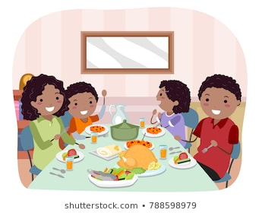
- Give your children responsibility to help with household chores – spray the window cleaner and clean the windows is a favourite!
- Look at Cosmic Kids Yoga on YouTube and join in together
- Sharing a family meal and talk about your day.
Physical Development
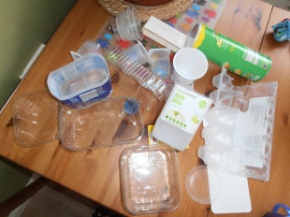
- Water play in the bath – scooping, pouring and measuring
- Design a treasure hunt around the house
- Junk modelling
- Make playdough together https://www.youtube.com/watch?v=jv73CEzY1jg
- Musical movement games – like musical statues
- Lego and block play. Plan to build something and see if you can follow your plan
- Phonics and dancing with Boom Shake the Alphabet
- Cutting with scissors.
- Threading/painting/colouring activities.
- Rough and tumble play
- Building dens and tunnels with blankets and under the kitchen table
Communication and Language
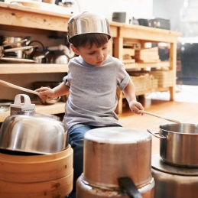
- Storytelling with homemade puppets – use old socks, lolly stick and straws
- Singing nursery rhymes and action songs, such as Simon Says
- Talking telephones made out of 2 plastic cups and string
- Play guessing games – such as think of an animal and model giving clues to help your child guess the animal
- Play board games
Maths
- Look for 2d/3d shapes around the house
- Playing Snakes and Ladders
- Bigger and Smaller games – describing the 3 Billy Goats Gruff or using Goldilocks
- Add numbers to pegs and the help your child to order them 1-10 (10-20)
- Measuring ingredients to cook/ help make dinner
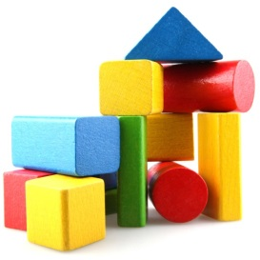
- Sing number songs, such as 5 currant buns or the Everybody Get Up counting song https://www.youtube.com/watch?v=aKvgwVAGSgw
- Sorting toys by height
- Sorting coins
- Build train tracks in different shapes
- Build towers from blocks – how many blocks did you use? Can you use the same blocks to build a different tower?
- https://www.bbc.co.uk/cbeebies/shows/numberblocks
Literacy
- Share story books and talk about what is happening on each page
- Play lotto games – matching pictures
- Tracing letters
- Hide an object in a ‘mystery bag’ and give clues to what might be inside
- Tap out syllables to break up your name on musical instruments.
- Encourage children to predict endings to stories
- Write shopping lists/letters/menus
Please put photos on Tapestry we would like to see what they are doing and stay in touch.

