[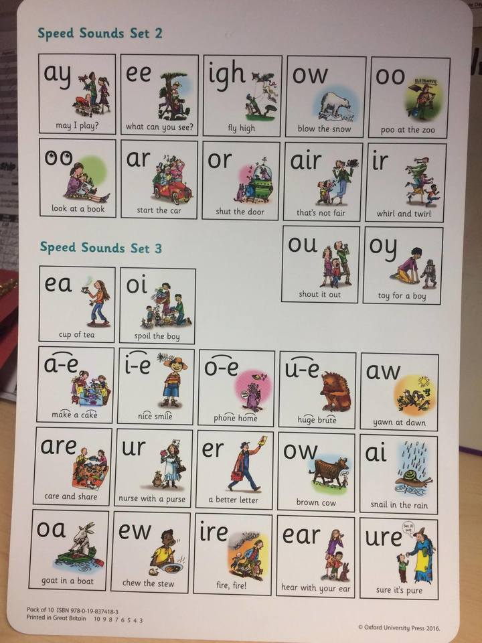](http://www.google.co.uk/url?sa=i&rct=j&q=&esrc=s&source=images&cd=&cad=rja&uact=8&ved=2ahUKEwjflcfDwObhAhWOlxQKHZqeDqoQjRx6BAgBEAU&url=http://www.bewseylodge.co.uk/learn_more/curriculum/read_write_inc_/&psig=AOvVaw1zGE5RhABvA-PNXgnWQB_6&ust=1556118806474036)