 | Monday 20th April | Tuesday 21st April | Wednesday 22nd April | Thursday 23rd April | Friday 24th April
20 mins | Literacy  Set 3 WRI sound a-e  Take your time with these sounds. we call them chatty friend and that is why we need to leave a space. So another friend can sit in the middle and stop them talking to each other  Spell 3 words; cake, bake,lake  and write the rhyme. bake a cake  RWI site free for parents if you need extra support.  https://www.ruthmiskin.com/en/find-out-more/help-during-school-closure/ | Literacy  Set 3 WRI sound a-e  Look at the sound again. Can they remember it? Why do we leave a gap?  Spell words a-e on the handout, which are on the blog. | Literacy  Set 3 WRI sound i-e.  Spell 3 words nice, smile, tile.  and write the rhym . nice smile  RWI site free for parents if you need extra support.  https://www.ruthmiskin.com/en/find-out-more/help-during-school-closure/ | Literacy  Set 3 WRI sound i-e  Look at the sound again. Can they remember it? Why do we leave a gap?  Spell words i-e on the handout, which are on the blog. | Literacy  Go over both of the sounds  a-e and I-e today. Say them and the rhyme, see if the children can remember how to write the sound? Can they think of any words with this sound in?  Refer to chart on blog.  look at other ay already taught ay- a-e and explain that there are two ways of writing a-e  do the same with i-e and I
10mins | Reading – can you read and talk about the story in your book.  Can you spot red words and special friend sounds? | Reading – can you read and talk about the story in your book.  Can you spot red words and special friend sounds? | Reading – can you read and talk about the story in your book.  Can you spot red words and special friend sounds? | Reading – can you read and talk about the story in your book.  Can you spot red words and special friend sounds? | Reading – can you read and talk about the story in your book.  Can you spot red words and special friend sounds?
5 mins | Practise red words. Hide them around the house or in the garden. | Practise red words. Play matching pairs. | Practise red words. Use a timer how many can you get in a minute. | Practise red words. Hide under cups and guess which one might be under it. | Encourage the children to write down as many red words as they can in 2minutes.
20mins | Maths.  Can you create a number poster using materials around the house of garden? Any number that they want to learn. Ask questions you have 3 How many more etc. see example below.  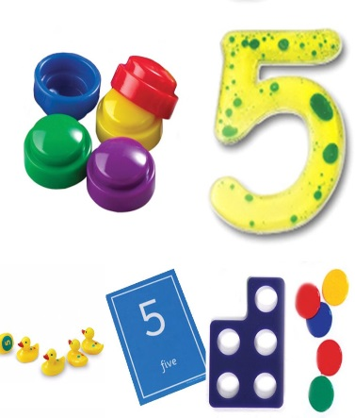 | Maths  Make up patterns using your body parts e.g. clap your hands, wiggle fingers, tap shoulders, nod head, knees, clap, shoulders, knees, clap, shoulders etc. Talk about what might and what might not come next.  Link to a website to support you in this area of learning:  Use You tube to watch the story being read aloud – Pattern bugs by Trudy Harris  GoNoodle – Dance to Banana, Banana Meatball  Can you think of any other ways of moving and then repeat them? E.g. flutter, crawl, flutter, crawl. | Maths  Activity: Investigate other was of making patterns e.g. red, green, green, red, green, green or big, big, small, big, big, small or yellow, yellow, red, red or big, big, small, small, small. Look at pictures of different patterns and ask your child to describe them e.g. they could describe the colours or the shapes.  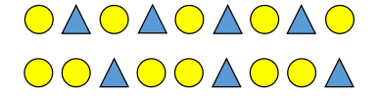  Can they draw their own patterns for you to describe? | Maths  Can you make a pattern that would fit exactly in these squares? Which type of patterns fit?  E.g. red, yellow  Red, yellow, blue  Red, blue, blue  Red, red, blue  Green, green, yellow, yellow  Pink, pink, brown, brown, red  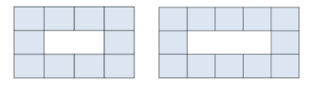 | Maths  Use a selection of fruit or vegetables to create a pattern on a kebab stick. Encourage your child to make it as complex as they feel! E.g. grape, strawberries, banana or if you prefer go outside and collect different objects to make patterns e.g. dandelion, stick, pebble, pebble, daisy, dandelion, stick, pebble, pebble, daisy etc. Perhaps you could photograph these?
10mins | Literacy  Look at letter formation this week. See blog for handwriting guide. Are the letters sitting correctly on the line, are they formed correctly and are the letters all a similar size?  Letters a,b,c,d, | Literacy  Look at letter formation this week. See blog for handwriting guide. Are the letters sitting correctly on the line, are they formed correctly and are the letters all a similar size?  Letters e, f, g, h | Literacy  .  Look at letter formation this week. See blog for handwriting guide. Are the letters sitting correctly on the line, are they formed correctly and are the letters all a similar size?  Letters I j, k, l | Literacy  Look at letter formation today. See blog for handwriting guide. Are the letters sitting correctly on the line, are they formed correctly and are the letters all a similar size?  m, n, o, p | Literacy  Look at letter formation today. See blog for handwriting guide. Are the letters sitting correctly on the line, are they formed correctly and are the letters all a similar size?  q,r,s,t
30mins | Physical exercise of your choice. | Physical exercise of your choice. | Physical exercise of your choice, | Physical exercise of your choice. | Physical exercise of your choice.

PARENT NOTE. IF YOUR CHILDREN ARE NOT SECURE ON THEIR SET 2 SOUNDS, THERE IS NO NEED TO RUSH AND GO ONTO SET 3 SOUNDS. I WILL PUT SET 2 SOUNDS UP ON THE BLOG FOR YOU TO CONTINUE PRACTISING WITH IN THE SAME WAY THAT WE HAVE BEEN DOING. IT IS BETTER FOR THE CHILDREN TO BE SECURE, THAN TO RUSH. YOU COULD TRY TO ENCOURAGE WRITING WITH SET 1 AND SET 2 SOUNDS, TO MAKE THEM MORE FAMILIAR WITH THE SOUNDS.

