 | Monday 20th April | Tuesday 21st April | Wednesday 22nd April | Thursday 23rd April | Friday 24th April
20 mins | Literacy  Set 3 WRI sound o-e  Take your time with these sounds. we call them chatty friend and that is why we need to leave a space. So another friend can sit in the middle and stop them talking to each other  Spell 3 words; toe, lone, home  and write the rhyme. Phone home  RWI site free for parents if you need extra support.  https://www.ruthmiskin.com/en/find-out-more/help-during-school-closure/ | Literacy  Set 3 WRI sound o-e  Look at the sound again. Can they remember it? Why do we leave a gap?  Spell words o-e on the handout, which are on the blog. | Literacy  Set 3 WRI sound u-e.  Spell 3 words rude, cube, huge .  and write the rhyme . huge brute  RWI site free for parents if you need extra support.  https://www.ruthmiskin.com/en/find-out-more/help-during-school-closure/ | Literacy  Set 3 WRI sound u-e  Look at the sound again. Can they remember it? Why do we leave a gap?  Spell words u-e on the handout, which are on the blog. | Literacy  Go over both of the sounds  a-e and I-e today. Say them and the rhyme, see if the children can remember how to write the sound? Can they think of any words with this sound in?  Refer to chart on blog.  look at ow- o-e do the same with oo- u-e,  see sheet on blog.
10mins | Reading – can you read and talk about the story in your book.  Can you spot red words and special friend sounds? | Reading – can you read and talk about the story in your book.  Can you spot red words and special friend sounds? | Reading – can you read and talk about the story in your book.  Can you spot red words and special friend sounds? | Reading – can you read and talk about the story in your book.  Can you spot red words and special friend sounds? | Reading – can you read and talk about the story in your book.  Can you spot red words and special friend sounds?
5 mins | Practise red words. Hide them around the house or in the garden. | Practise red words. Play matching pairs. | Practise red words. Use a timer how many can you get in a minute. | Practise red words. Hide under cups and guess which one might be under it. | Encourage the children to write down as many red words as they can in 2minutes.
20mins | Maths.  BBC Number blocks episode 14 , I can count to 20.  https://www.bbc.co.uk/iplayer/episode/m0006s5q/numberblocks-series-4-14-i-can-count-to-twenty  Let’s start by counting to 20 out loud. Can you say it in a loud voice? Can you say it in a teeny tiny mouse voice? How else can you count to 20?  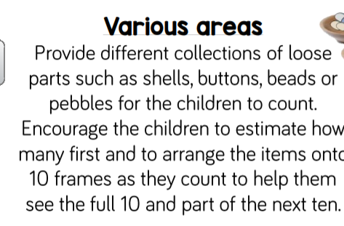 | Maths  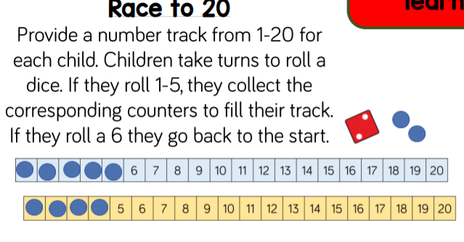 | Maths  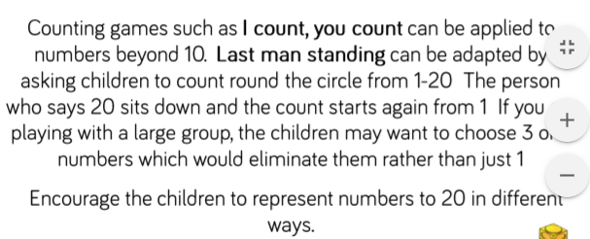 | Maths  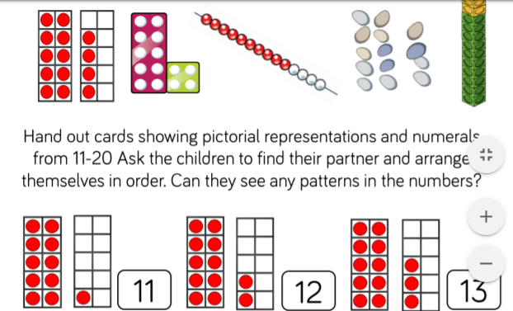  You can find these cards on twikle? | Maths  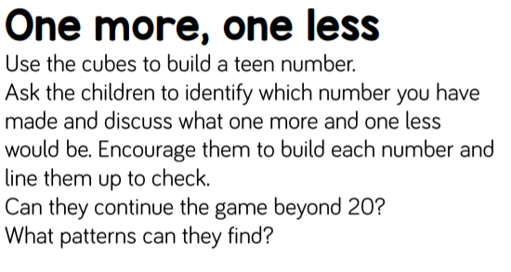
10mins | Literacy  Look at letter formation this week. See blog for handwriting guide. Are the letters sitting correctly on the line, are they formed correctly and are the letters all a similar size?  Letters uvw | Literacy  Look at letter formation this week. See blog for handwriting guide. Are the letters sitting correctly on the line, are they formed correctly and are the letters all a similar size?  Letters yzx | Literacy  Can you write about what you enjoyed at school? It could be going to the Aquarium, the Christmas Play, friendships, Forest School, cooking, parachute games, learning etc,, | Literacy  Can you hold and write a sentence? See Blog page.  This all does not need to be done today. Just take Thursday | Literacy  Can you hold and write a sentence? See Blog page.  This all does not need to be done today. Just take Friday.
30mins | Physical exercise of your choice. | Physical exercise of your choice. | Physical exercise of your choice, | Physical exercise of your choice. | Physical exercise of your choice.

PARENT NOTE. IF YOUR CHILDREN ARE NOT SECURE ON THEIR SET 2 SOUNDS, THERE IS NO NEED TO RUSH AND GO ONTO SET 3 SOUNDS. IT IS BETTER FOR THE CHILDREN TO BE SECURE, THAN TO RUSH. YOU COULD TRY TO ENCOURAGE WRITING WITH SET 1 AND SET 2 SOUNDS, TO MAKE THEM MORE FAMILIAR WITH THE SOUNDS.

