 | Monday 11th May | Tuesday 12th May | Wednesday 13th May | Thursday 14th May | Friday 15th May
20 mins | Literacy  Set 3 WRI sound aw  Spell 3 words; saw, draw, lawn  and write the rhyme. Yawn at dawn  RWI site free for parents if you need extra support.  https://www.ruthmiskin.com/en/find-out-more/help-during-school-closure/ | Literacy  Set 3 WRI sound aw  Look at the sound again. Can you remember it? What is the rhyme ?  Spell words aw on the handout, which are on the blog. | Literacy  Set 3 WRI sound are (note for parents say this sound as air.)  Spell 3 words care, flare, stare  and write the rhyme. care and share  RWI site free for parents if you need extra support.  https://www.ruthmiskin.com/en/find-out-more/help-during-school-closure/ | Literacy  Set 3 WRI sound are  Look at the sound again. Can they remember it?  Spell are words flare, dare, care  Spell air words chair, hair, | Literacy  Go over both of the sounds  aw and are today. Say them and the rhyme, see if the children can remember how to write the sound? Can they think of any words with this sound in?  Refer to chart on blog.  look at aw , or do the same with air,are
10mins | Reading – can you read and talk about the story in your book.  Can you spot red words and special friend sounds? | Reading – can you read and talk about the story in your book.  Can you spot red words and special friend sounds? | Reading – can you read and talk about the story in your book.  Can you spot red words and special friend sounds? | Reading – can you read and talk about the story in your book.  Can you spot red words and special friend sounds? | Reading – can you read and talk about the story in your book.  Can you spot red words and special friend sounds?
5 mins | Practise red words. Hide them around the house or in the garden. | Practise red words. Play matching pairs. | Practise red words. Use a timer how many can you get in a minute. | Practise red words. Hide under cups and guess which one might be under it. | Encourage the children to write down as many red words as they can in 2minutes.
20mins | Maths  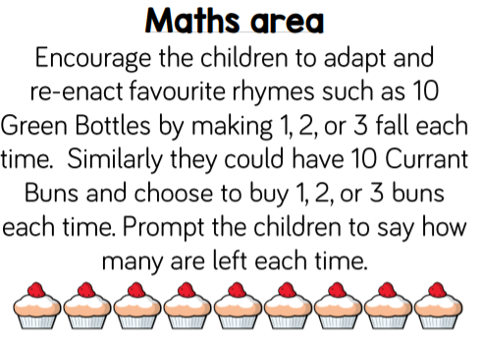 | Maths  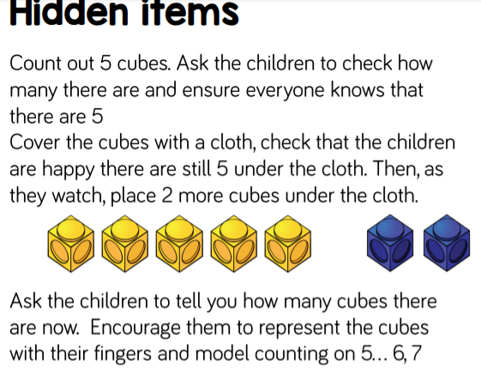 | Maths  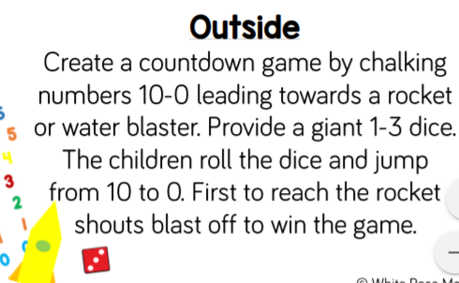 | Maths  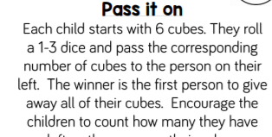  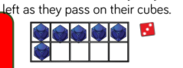 | Maths  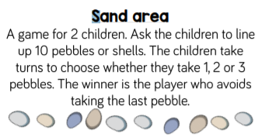
10mins | Literacy  Write a sentence about what you know about China.  Challenge: Try and make your writing really neat so someone else can read it! | Literacy  Talk with your grown up, about China.  Write a sentence describing what you like about China. | Literacy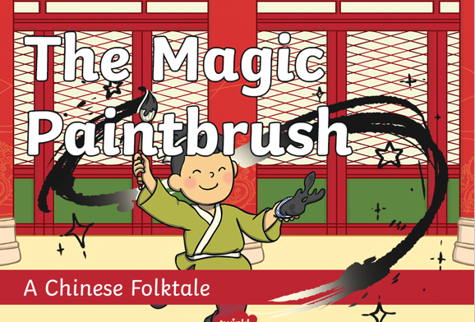  Listen to the story Dragons in the City.  What did Ma Liang llike doing?  What did Ma Liang find on his desk?  Who was Ma Liang helping?  What did you think about the rich man? | Literacy  Recap the story if needed. Talk about the different pictures (see attached) and what is happening in each one. Encourage your child to finish the sentences. Can they make them longer using the conjunction ‘and’? There is a blank sheet if your child prefers to draw their own part of the story and write about it. | Literacy  Look in other books to identify speech bubbles. These show us what a character might be saying. Complete the speech bubbles on the sheet (see below.)  What might you say if  Ma Liang wanted to draw something for you
30mins | Physical exercise of your choice. | Physical exercise of your choice. | Physical exercise of your choice, | Physical exercise of your choice. | Physical exercise of your choice.

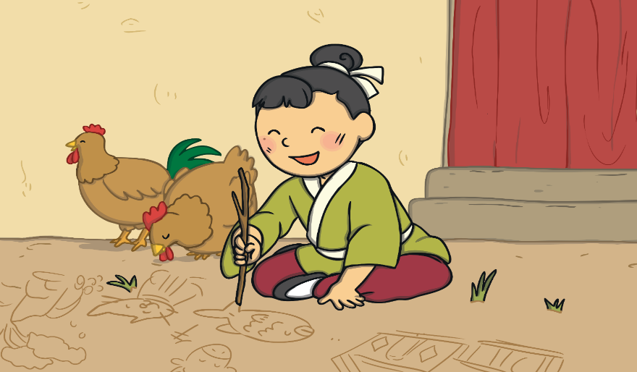 | All of a sudden_______________  ___________________________
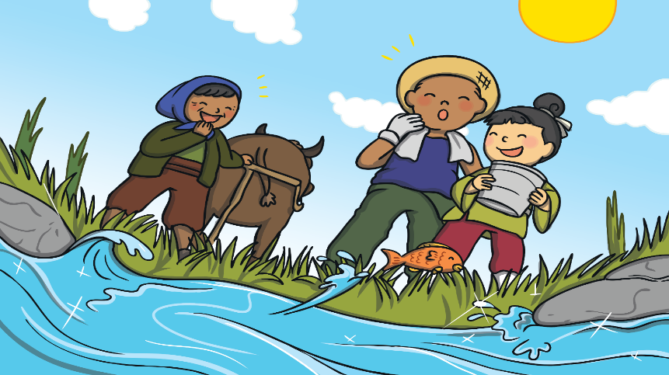 | But when ___________________  ___________________________
___________________________

___________________________
___________________________

___________________________

