HERE ARE 17 FUN FACTS ABOUT YELLOWSTONE NATIONAL PARK:
- Yellowstone was established on March 1, 1872.
- It is the world's first national park.
- It contains 3,472 square miles and measures 63 miles north to south and 54 miles east to west
- The park is 96% in Wyoming, 3% in Montana, and 1% in Idaho.
- The highest point in the park is 11,358' at Eagle Peak and the lowest point in the park is 5,282' at Reese Creek.
- Yellowstone is larger than Rhode Island and Delaware combined.
- Yellowstone has 1000 to 3000 earthquakes annually.
- There are more than 300 active geysers
- There are more than 290 waterfalls.
- Yellowstone is home to 67 species of mammals, 285 species of birds, 16 species of fish, 6 species of reptiles, 5 species of amphibians, and more than 7 aquatic nuisance species.
- Two threatened species call the park home - Canada lynx and Grizzly bears. Wolverines are a proposed threatened species.
- Yellowstone has more than 1800 archaeological sites.
- There are 5 park entrances and 466 miles of roads.
- There are 15 miles of boardwalk.
- There are 92 trailheads that access approximately 1000 miles of trails.
- In 2015, Yellowstone National Park had 4,097,710 visits - a park record.
- Old Faithful, a geyser, erupts every 92 minutes on average.
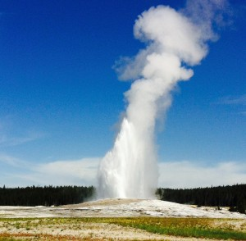
Old Faithful Geyser
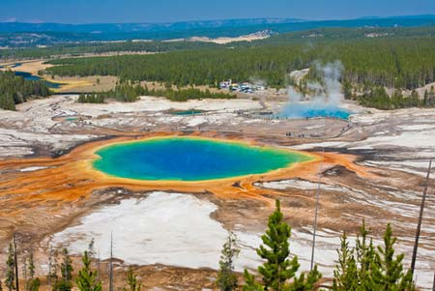
Grand Prismatic Spring

