 | Monday 11th May | Tuesday 12th May | Wednesday 13th May | Thursday 14th May | Friday 15th May
20 mins | Literacy 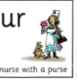  Set 3 WRI sound ur  Spell 3 words; nurse , purse , church  and write the rhyme. Nurse with a purse  RWI site free for parents if you need extra support.  https://www.ruthmiskin.com/en/find-out-more/help-during-school-closure/ | Literacy  Set 3 WRI sound  Look at the sound again. Can you remember it? What is the rhyme ?  Read words ur on the handout, which are on the blog. | 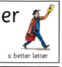  Literacy  Set 3 WRI sound  Spell 3 words butter, letter, germ  and write the rhyme. A better letter.  RWI site free for parents if you need extra support.  https://www.ruthmiskin.com/en/find-out-more/help-during-school-closure/ | Literacy  Set 3 WRI sound  Look at the sound again. Can they remember it?  Can they find and read the er words on the blog page. | Literacy  Go over both of the sounds  ur and er today. Say them and the rhyme, see if the children can remember how to write the sound? Can they think of any words with this sound in?  Refer to chart on blog.  look at er, ur.
10mins | Reading – can you read and talk about the story in your book.  Can you spot red words and special friend sounds? | Reading – can you read and talk about the story in your book.  Can you spot red words and special friend sounds? | Reading – can you read and talk about the story in your book.  Can you spot red words and special friend sounds? | Reading – can you read and talk about the story in your book.  Can you spot red words and special friend sounds? | Reading – can you read and talk about the story in your book.  Can you spot red words and special friend sounds?
5 mins | Practise red words. Hide them around the house or in the garden. | Practise red words. Play matching pairs. | Practise red words. Use a timer how many can you get in a minute. | Practise red words. Hide under cups and guess which one might be under it. | Encourage the children to write down as many red words as they can in 2minutes.
20mins | Maths  Watch cbeebies, series 2 ,episode 9, double trouble.  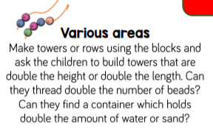 | Maths  if you do not have dominoes, you could draw them on to paper.  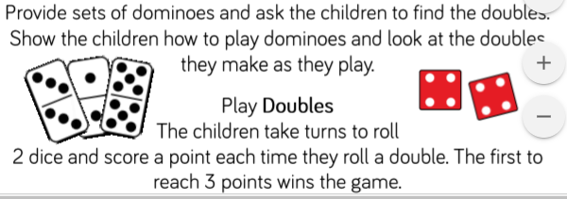 | Maths  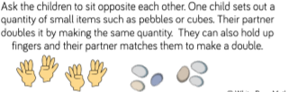 | Maths  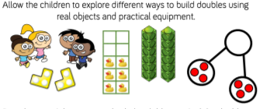 | Maths  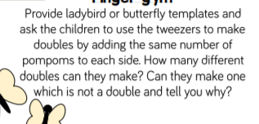
10mins | Literacy  See presentation on the blog page 1. | Literacy  See presentation on the blog page 2. | Literacy  See presentation on the blog page 3. | Literacy  See presentation on the blog page 4. | Literacy  See presentation on the blog page 5.
30mins | Physical exercise of your choice. | Physical exercise of your choice. | Physical exercise of your choice, | Physical exercise of your choice. | Physical exercise of your choice.

