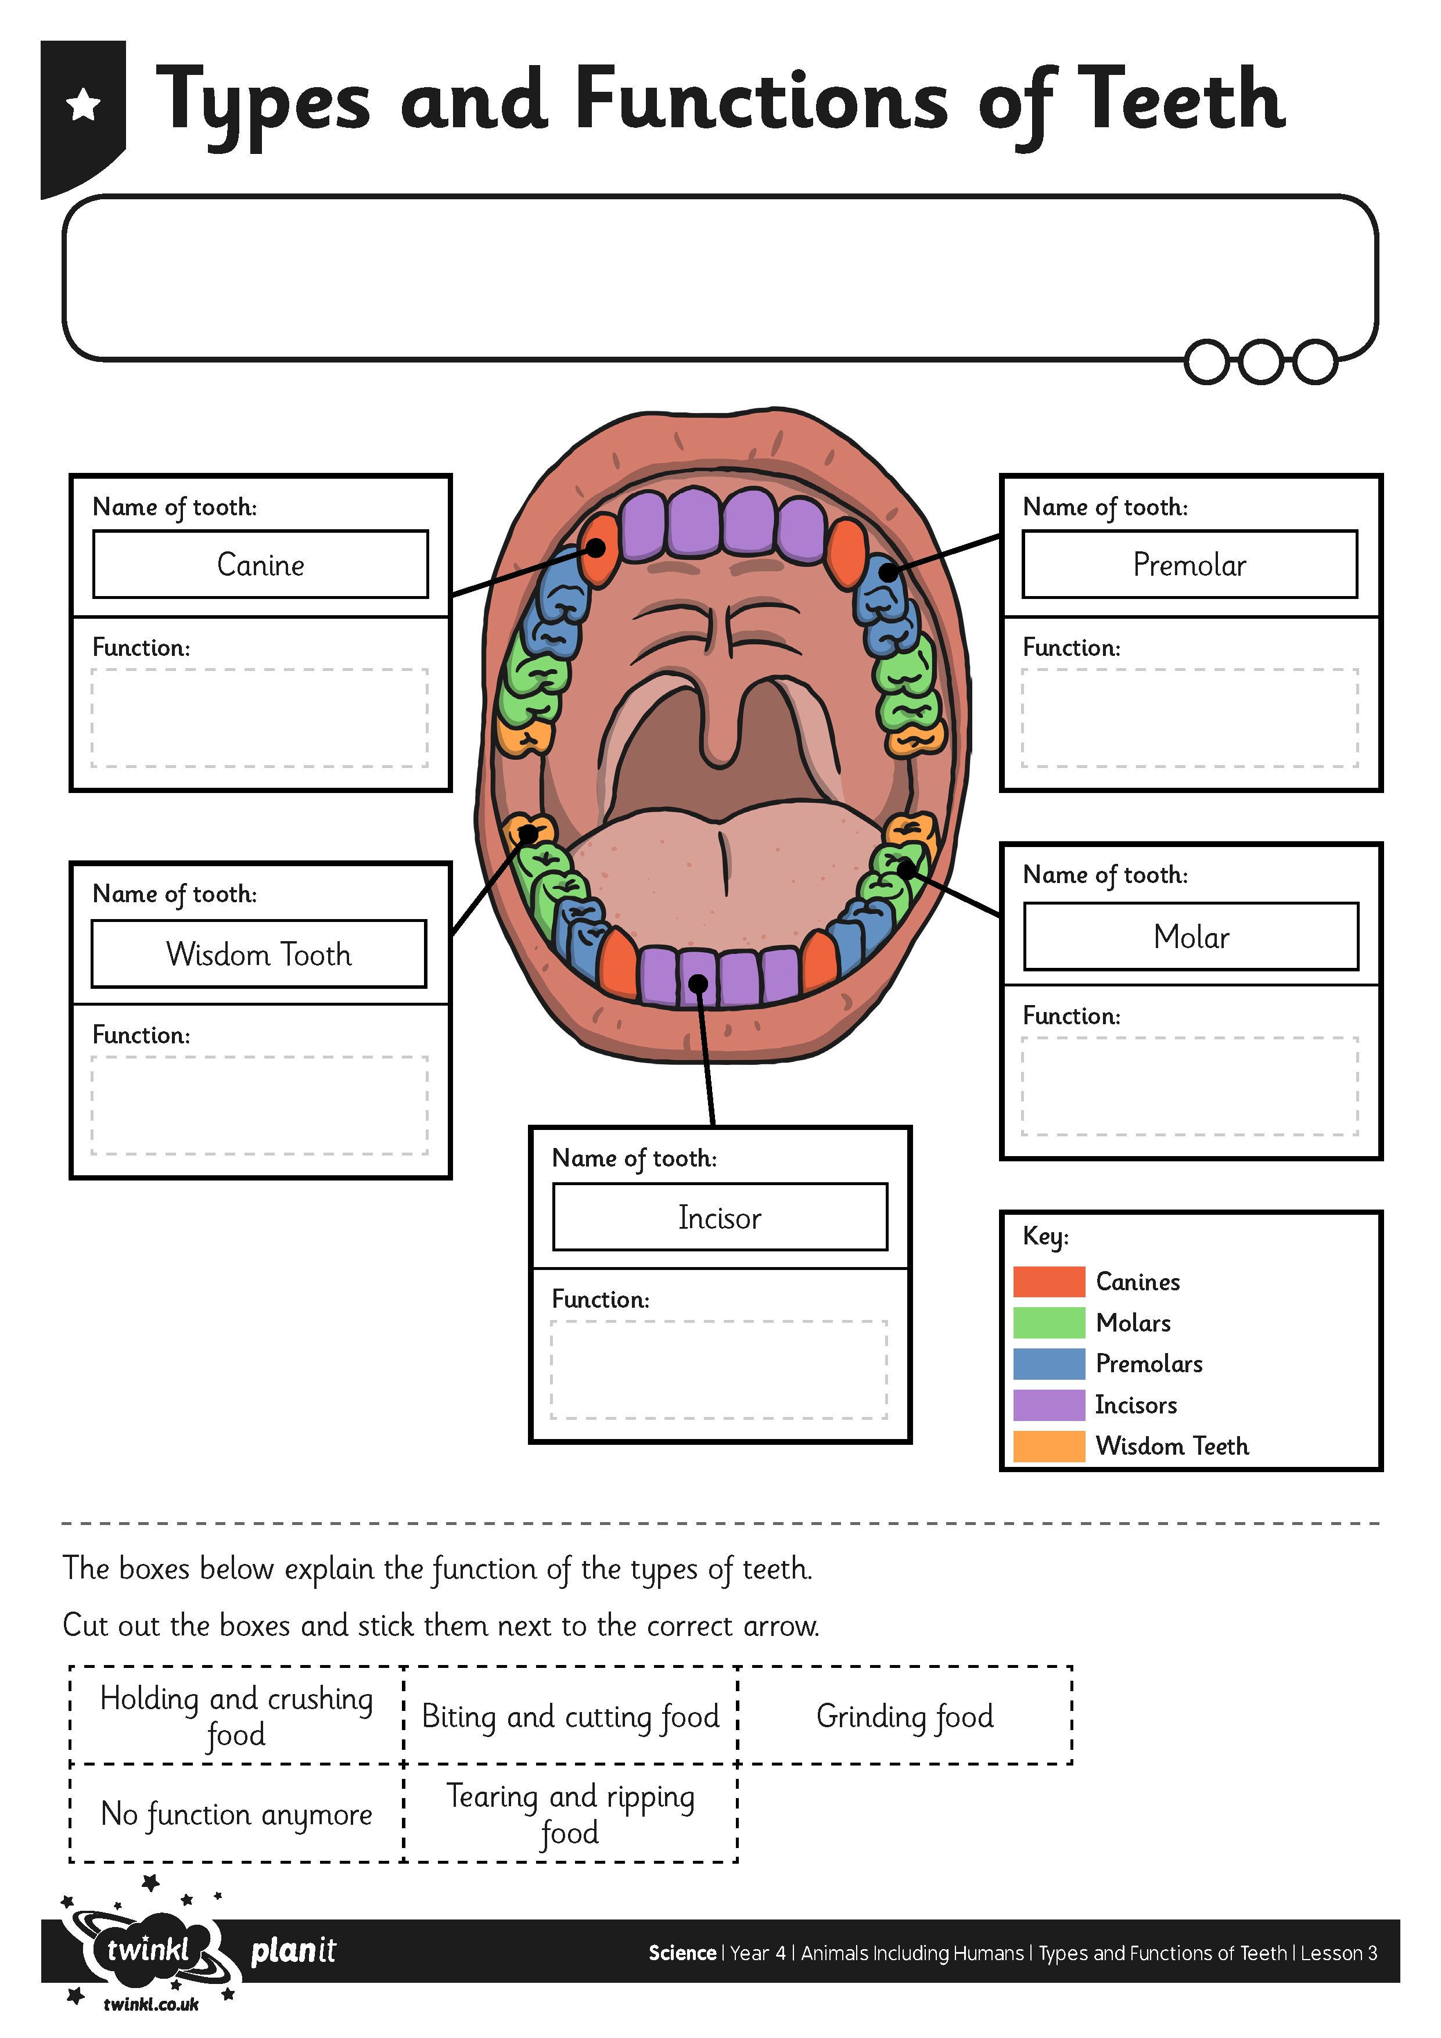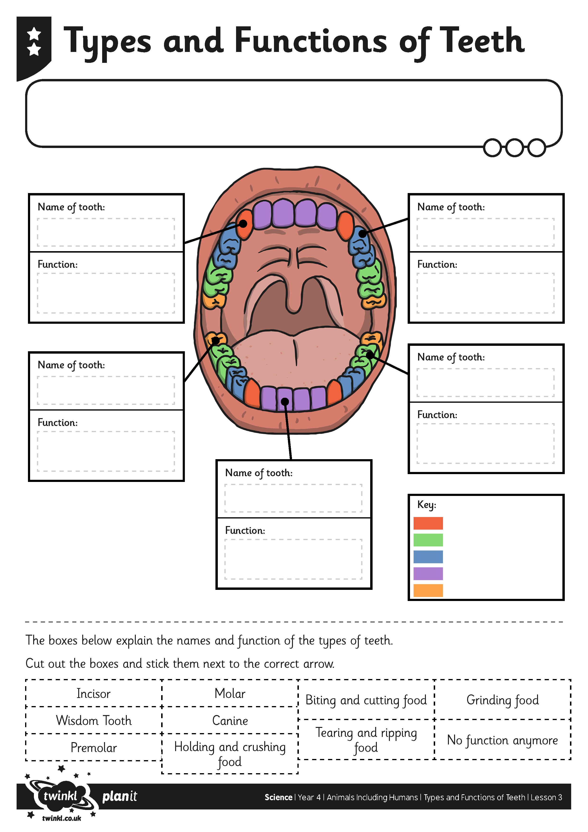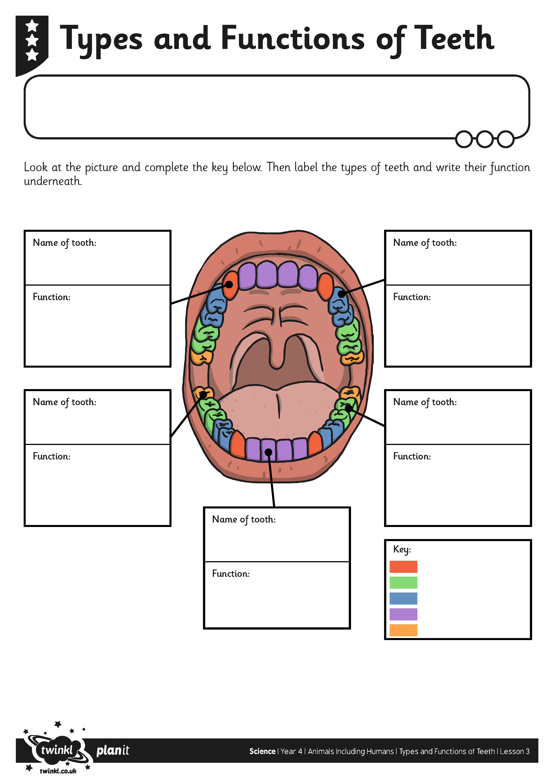
I can identify the types and functions of teeth.

I can identify the types and functions of teeth.

I can identify the types and functions of teeth.

