Monday | Tuesday | Wednesday | Thursday | Friday
Topic.  Can you make a Chinese drum and play along with some Chinese music? What do you notice about the beat?  https://www.youtube.com/watch?v=BXq_pvERGUM  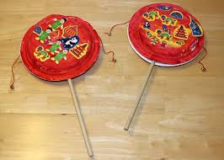 | Well being.  Get dressed and go for a run today see if you can run for 5 minutes without stopping. You might even be able run for longer, but you will need to pace yourself. | Topic  Research typical female Chinese outfits and learn why they wear them. | Well being  Write down or talk about  3 good things that have happened this week. What is your favourite thing that you have done and why? | Inset Day.

