 | Monday 8th June | Tuesday 9th June | Wednesday 10th June | Thursday 11th June |  | Friday 12th June
20 mins | Phonics  Set 3 WRI sound  Spell 3 words chew, flew, grew  and write the rhyme. Chew the stew.  RWI site free for parents if you need extra support.  https://www.ruthmiskin.com/en/find-out-more/help-during-school-closure/ | Phonics  Set 3 WRI sound  Look at the sound again. Can you remember it? What is the rhyme?  Cut stick and spell ew words, on the handout, which are on the blog. | Phonics  Set 3 WRI sound ai  Spell 3 words fire, spire, hire  and write the rhyme. Fire fire  RWI site free for parents if you need extra support.  https://www.ruthmiskin.com/en/find-out-more/help-during-school-closure/ | Phonics  Set 3 WRI sound  Look at the sound again. Can you remember it? What is the rhyme?  Cut, stick and spell ire words on the handout, which are on the blog. |  | Phonics  Today look at all the set 3 sounds that you have learned and see which ones you can recognise.  Give yourself a big pat on the shoulder to get this far you are doing incredibly well.
10mins | Reading – can you read and talk about the story in your book.  Can you spot red words and special friend sounds? | Reading – can you read and talk about the story in your book.  Can you spot red words and special friend sounds? | Reading – can you read and talk about the story in your book.  Can you spot red words and special friend sounds? | Reading – can you read and talk about the story in your book.  Can you spot red words and special friend sounds? |  | Reading – can you read and talk about the story in your book.  Can you spot red words and special friend sounds?
5 mins | Practise red words. Play matching pairs. | Practise red words. Use a timer how many can you get in a minute. | Practise red words. Hide under cups and guess which one might be under it. | Encourage the children to write down as many red words as they can in 2minutes. |  | Practise red words. Play matching pairs.
20mins | Maths  Odds and evens  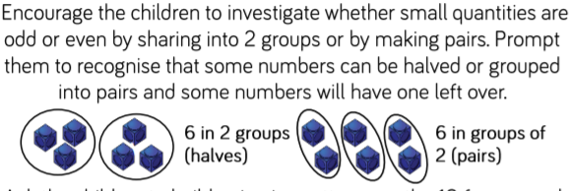 | Maths  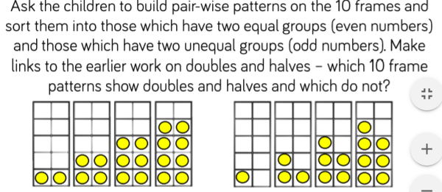 | Maths  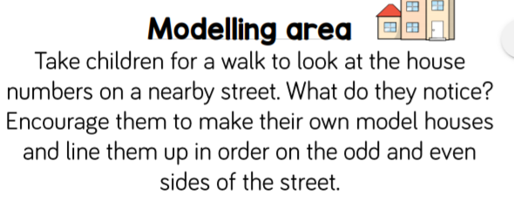 | Maths  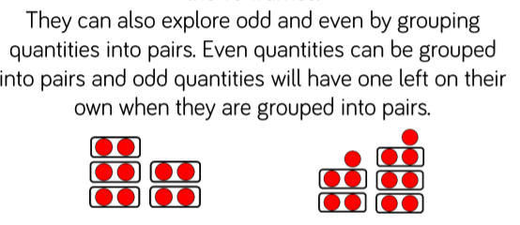 | Maths  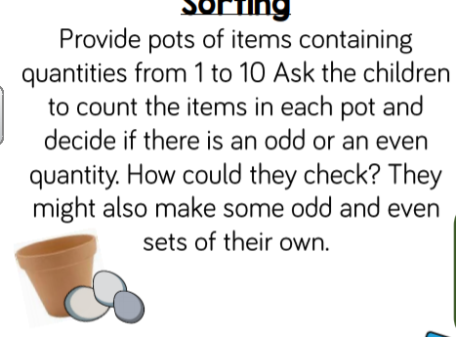
10mins | Literacy  Practise your letter formation write the alphabet in lower case. Check to see if you can spot any mistakes. | Literacy  Make a poster using felt tip pens or crayons and write three red words lots of times using rainbow colours .Find some where to display your poster. | Literacy  Upper and lower case letters. Check to see if you can match them correctly. Can you tell your adult when you should use a capital letter? | Literacy  Can you write 3 facts about a Panda? | Literacy  Write a list of 5 rhyming words.  Can you think of words that rhyme with dig.
30mins | Physical exercise of your choice. | Physical exercise of your choice, | Physical exercise of your choice. | Physical exercise of your choice. | Physical exercise of your choice

