Monday | Tuesday | Wednesday |  | Thursday | Friday
Topic  What can you find out about the Giant Panda? What colour is its tail? What colour are new born Pandas? Why are pandas special in china? What river can be found near in China?  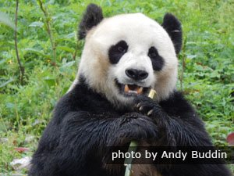 | Wellbeing.  Sit comfortably outside, or even make a den and read a page or two of your favourite book.  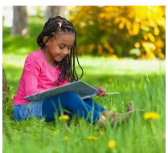 |  | Topic  China is made up of lots of different languages such as Mandarin. Can you learn how to say hello in Chinese? You could even try to write it.  你好 | Wellbeing  Draw around your hand a write down what you have enjoyed this week. List your friends or favourite things.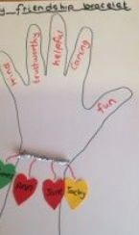 | Topic  China produces much of its own food. Can you find 3 things that they grow in grow in China?  