Year 2 Home-Learning

Week Commencing 15th June, 2020

Reading  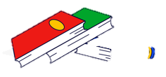 | Complete The Rainbow Serpent comprehension.  Gold – Can you create three of your own questions about the text and ask someone in your family to answer them?
Writing | Listen and read the story of Tiddalik the Frog. Part 1 and Part 2 can be found on the BBC website.  https://www.bbc.co.uk/programmes/articles/zbpyLd7T35C9B3GlYmTRLd/tiddalikthe-frog-1-tiddalik-the-frog-was-thirsty-thirsty  Can you draw and write a storyboard of Tiddalik the Frog.  Gold – Add adverbs to your storyboard.
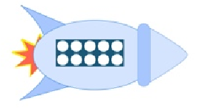Maths | Complete Week 8 of the White Rose lessons.  Worksheets are on the blog.  Gold – Play hit the button to practise your times tables  http://www.topmarks.co.uk/maths-games/hit-the-button
PE | Can you join in with PE with Joe Wicks each morning?  Gold – Complete a few Go Noodle guided dance activities.
Science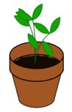 | Draw 4 things that you do every day to stay clean.  Gold – Design your own soap bottle.
Art/DT | Can you make Anzac biscuits?  Gold – Can you create your own recipe page for Anzac biscuits?
Music | Listen to the Tiddalik the story song, complete the tutorial and the music activity.  https://www.bbc.co.uk/programmes/articles/zbpyLd7T35C9B3GlYmTRLd/tiddalikthe-frog-1-tiddalik-the-frog-was-thirsty-thirsty  Gold – Can you clap the rhythm of your favourite song?

