Monday | Tuesday | Wednesday |  | Thursday | Friday
Topic  https://www.youtube.com/watch?v=WQK4tAKNllo  can you name 2 Chinese national treasures?  How many days does Chinese New Year last for?  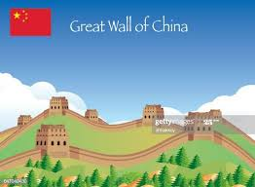  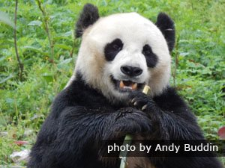 | Wellbeing.  Make a fathers/grandad/friend card. Have a go at writing’ I love you this much’ yourself and this will make the card extra special.  A choice of 2 the bottom one is on the blog page.  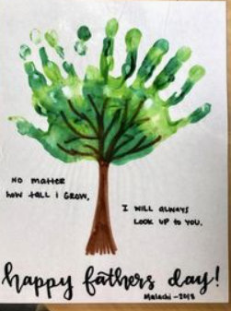  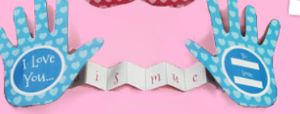 |  | Topic  Fact busters.  Cricket is England’s National  Sport.  Can you find out what is China’s national Sport?  https://www.twinkl.co.uk/resource/t-t-17150-china-resource-pack  What is the main religion in China?  https://kids.kiddle.co/Religion_in_China | Wellbeing.  Another scavenger hunt!!! outside, but this time try to find things that follow the alphabet.  Sheet attached on the blog.  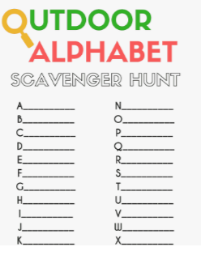 | Topic  This is the last day of our topic.  Can you write down the answer to our topic question ‘what makes China Unique?’ You could even stick some pictures on to an a4 piece of paper and label them.

