 | Monday 15th June | Tuesday 16th June | Wednesday 17th June | Thursday 18th June |  | Friday 19th June
20 mins | 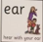  Rwi sound ear  Spell 3 words; fear, near, rear  write the rhyme hear with your ear.  Phonics  Set 3 WRI sound  RWI site free for parents if you need extra support.  https://www.ruthmiskin.com/en/find-out-more/help-during-school-closure/ | Phonics  Set 3 WRI sound  Look at the sound again. Can you remember it? What is the rhyme?  spell ear words, on the handout, which are on the blog. | 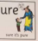  Set 3 WRI sound ure  Spell 3 words sure, pure, cure  and write the rhyme. Sure its pure.  RWI site free for parents if you need extra support.  https://www.ruthmiskin.com/en/find-out-more/help-during-school-closure/ | Look at the sound again. Can you remember it? What is the rhyme?  spell ure words on the handout, which are on the blog. |  | This is our first visit to set 3 complete.  Go over all the sounds together.  Play games such as hiding the sound, saying the rhyme, spelling a word.  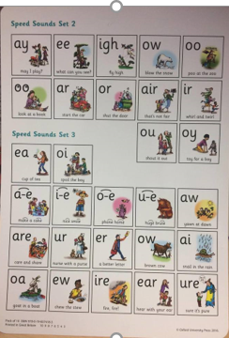
10mins | Reading – can you read and talk about the story in your book.  Can you spot red words and special friend sounds? | Reading – can you read and talk about the story in your book.  Can you spot red words and special friend sounds? | Reading – can you read and talk about the story in your book.  Can you spot red words and special friend sounds? | Reading – can you read and talk about the story in your book.  Can you spot red words and special friend sounds? |  | Reading – can you read and talk about the story in your book.  Can you spot red words and special friend sounds?
5 mins | Practise red words. Play matching pairs. | Practise red words. Use a timer how many can you get in a minute. | Practise red words. Hide under cups and guess which one might be under it. | Encourage the children to write down as many red words as they can in 2minutes. |  | Practise red words. Play matching pairs.
20mins | Maths  Practise drawing different worms of different lengths. Make sure they have lots of small horizontal lines in the body – these look like our number lines we use in school. How many different numbers lines can you make? Draw your worms and add numbers but make sure you start at different numbers not always 1 or 0!  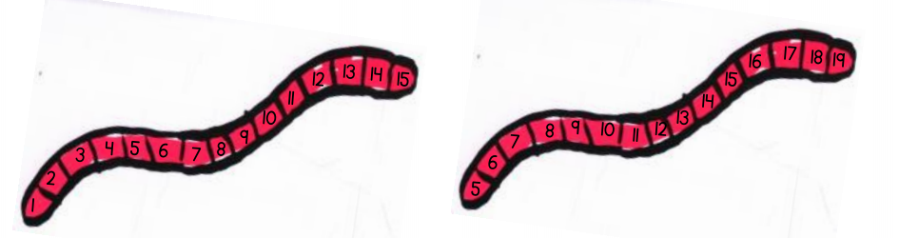  Challenge: Can you write a number line starting from a larger number and counting backwards? | Maths  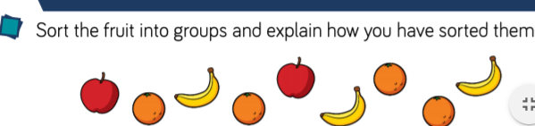 | Maths  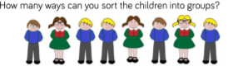 | Maths  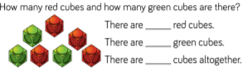 |  |  | Maths  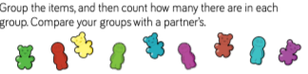
10mins | Literacy  Read the attached Chinese poem together.  What do you notice?  Could you make up another 2 lines to the poem, using the same pattern?  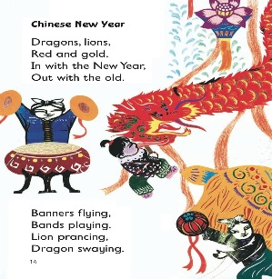 | Literacy  Activity: Read ‘African Animals’ and learn it together by creating actions to match the poem e.g. Giraffe – arms stretched above your head, stand on tiptoes. Choose your favourite African animal and paint/draw your chosen one. Add sentences to describe the animal e.g. Elephants trunks are big and long. | Literacy  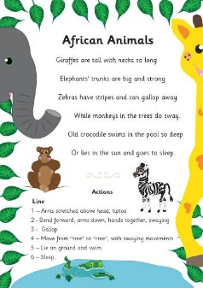  Talk about adjectives ie big, strong can you highlight all the adjectives.  Can you make a list of adjectives to describe a panda?  https://www.bbc.co.uk/bitesize/topics/zrqqtfr/articles/zy2r6yc | Literacy  Make a poster using felt tip pens or crayons and write three different red words lots of times using rainbow colours. Find some where to display your poster.  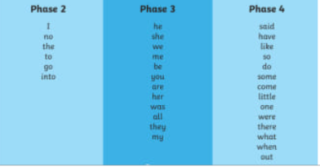 | Literacy  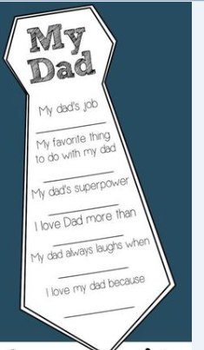  Using a tie template write, what you know and like about the person you are going to give it to. Try to use some adjectives.
30mins | Physical exercise of your choice. | Physical exercise of your choice, | Physical exercise of your choice. | Physical exercise of your choice. | Physical exercise of your choice

Maths continued

challenge: keep learning to count in 2’s and 5’s. Can you count to 10 or even 20?

Literacy Poems;

