 | Monday 22nd June  Revisit set 3 sounds | Tuesday 23rd June | Wednesday 24th June | Thursday 25th June | Friday 26^{h} June
20 mins | Make this a writing only day. Practise your speed sounds for set 2. Use the’ Speed sound patter’ sheet to practise writing each letter correctly making sure you use the correct sequence.  Are your letter sizes all a similar size? Do they sit correctly on the line?  https://www.bbc.co.uk/bitesize/topics/zvq9bdm  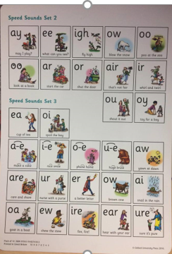 | Write some set 1&2 words (chew, shout, see, three, book, may, high, boy, fair) don’t let your child copy the words, they must Fred talk them for themselves.  https://www.bbc.co.uk/bitesize/topics/zvq9bdm | Have a go at writing the Set 3 or set 2 sounds you have learnt. Can you write them without looking at them first?  Can you sound out any words with a sound in them?  , | Can you write the ea sound?  Spell words  Tea, bean, beat ,beach.  Write the sentence .  I went to the beach . remember finger spaces, capital letters and full stops. | Look at this sound and discuss how it sounds like ea but it is the ee.  Sound.  Spell  Three, free, tree, bee.  See ea and ee worksheet below.
10mins | Reading – can you read and talk about the story in your book.  Can you spot red words and special friend sounds? | Reading – can you read and talk about the story in your book.  Can you spot red words and special friend sounds? | Reading – can you read and talk about the story in your book.  Can you spot red words and special friend sounds? | Reading – can you read and talk about the story in your book.  Can you spot red words and special friend sounds? | Reading – can you read and talk about the story in your book.  Can you spot red words and special friend sounds?
5 mins | Practise red words. Play matching pairs. | Practise red words. Use a timer how many can you get in a minute. | Practise red words. Hide under cups and guess which one might be under it. | Encourage the children to write down as many red words as they can in 2minutes. | Practise red words. Play matching pairs.
20mins | Maths  1more  Please see sheet attached to the blog page.  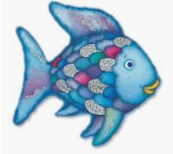 | Maths  Counting  Please see counting sheet attached to the blog page. | Maths  Practice counting in 2’s  https://www.youtube.com/watch?v=GvTcpfSnOMQ  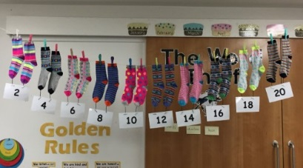 | Maths  Practice counting in 5s  https://www.youtube.com/watch?v=EemjeA2Djjw  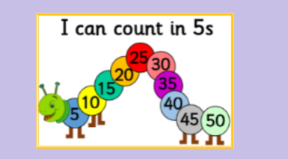 | Maths  Practise counting in 5s  https://www.youtube.com/watch?v=Ftati8iGQcs  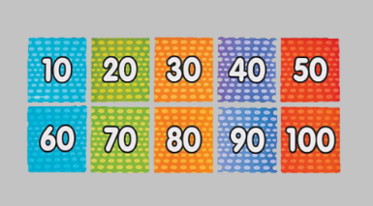
10mins | Literacy  Read the story of the rainbow fish together  https://www.youtube.com/watch?v=r9mryuEKkKc  Questions for your child. DURING Reading the story…  ASK: How does the rainbow fish feel about sharing? What do you think he should do? Why? How do the other fish feel about the rainbow fish?  SHOW: Talk about the art style and colours. Talk about the different ocean life pictured.  CONNECT: Many sea creatures live in groups that need each other. Other sea creatures live alone. Do people live in groups or alone? Do we need each other? Does the rainbow fish need other fish? | Literacy  Book review.  See blog  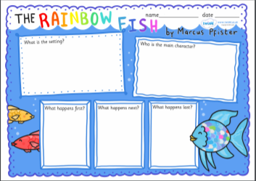 | Literacy  Fill in the writing prompts that are on the Blog page linked to the Rainbow Fish.  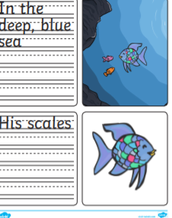 | Literacy  Can you spot and correct the mistakes in the sentences?  See blog page.  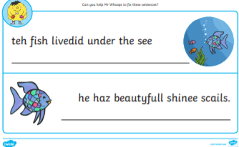 | Literacy  Word search.  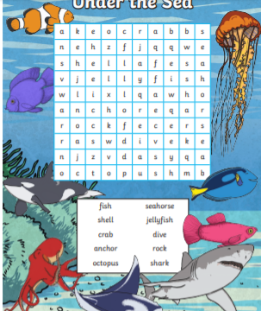
30mins | Physical exercise of your choice. | Physical exercise of your choice, | Physical exercise of your choice. | Physical exercise of your choice. | Physical exercise of your choice

