Year 2 Home-Learning
Week Commencing 29th June, 2020

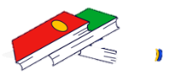Reading | Complete the ‘Kangaroo Kid’ comprehension and then create 2 questions of your own.  Gold – Read a non-fiction text and complete the book review.
Writing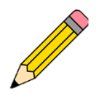 | Have a look at the whale story map. Can you research or create your own whale? Draw a picture of it and write a description about it. Remember to use expanded noun phrases and a thesaurus if you have one.  Gold – Can you go on an apostrophe hunt and then use some of the words you find in your whale description?
Maths  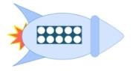 | Complete the White Rose week 10 work. See the blog for attachments.
PE  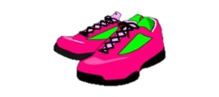 | Can you complete some of the tennis activities?  Gold – Make up an obstacle course for someone in your family. You could even time it and see who can complete it first!
Science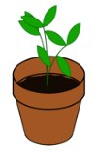 | Can you complete the dissolving science experiment? Remember to try and make a prediction about which solids will dissolve and which won’t and record your findings on the table. If you want to use different solids you could create your own table.  Gold – Write a conclusion about your experiment.
Art/DT  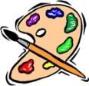 | Can you make a fish, shark, whale or any other under the sea creature out of a water bottle? There are lots of examples below! We would love to see any of your creations. Please send a picture via email to secretary@stcleerprimary.co.uk for us to see them.
Music  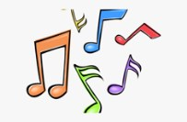 | Listen to the song I’m a Kangaroo Do Do Do https://www.youtube.com/watch?v=e9mwp7GIpl0 Can you create your own actions to the song?




