 | Monday 29th June  Revisit set 3 sounds | Tuesday 30th June | Wednesday 1st July | Thursday 2nd July | Friday 3rd July
20 mins | Have a look at some Alien words today. These are words, which try to catch us out. See blog. | Write some set 1&2 words, spray, book, foot, shut, say, see, stir, boy, snail, stew don’t let your child copy the words, they must Fred talk them for themselves.  https://www.bbc.co.uk/bitesize/topics/zvq9bdm | Have a go at writing the Set 3 or set 2 sounds you have learnt. Can you write them without looking at them first?  Can you sound out any words with a sound in them?  ,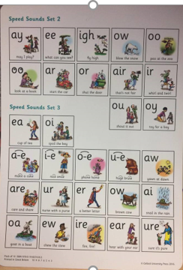 | Can you write the igh sound?  Spell words  High, fright, might.Write the sentence .  I had a fright on my way to the park.  remember finger spaces, capital letters and full stops. | Look at this sound and discuss how it sounds like igh but it is the i-e.  Sound.  Spell  bike, write, five.  Write the sentence  At five I rode my bike to the shop.  .
10mins | Reading – can you read and talk about the story in your book.  Can you spot red words and special friend sounds? | Reading – can you read and talk about the story in your book.  Can you spot red words and special friend sounds? | Reading – can you read and talk about the story in your book.  Can you spot red words and special friend sounds? | Reading – can you read and talk about the story in your book.  Can you spot red words and special friend sounds? | Reading – can you read and talk about the story in your book.  Can you spot red words and special friend sounds?
5 mins | Practise red words. Play matching pairs. | Practise red words. Use a timer how many can you get in a minute. | Practise red words. Hide under cups and guess which one might be under it. | Encourage the children to write down as many red words as they can in 2minutes. | Practise red words. Play matching pairs.
20mins | Maths  Counting  Count to 10 in 2s  See the page below  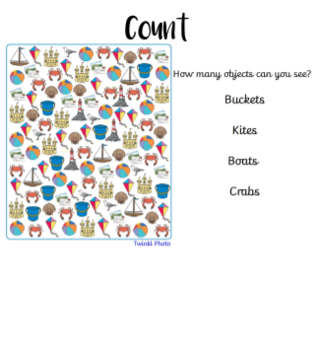 | Maths  Count to 20 in 2s.  Watch the clip and try to join in https://www.youtube.com/watch?v=mXMofxtDPUQ What is today ? Can they name the days of the week? Which days are at the weekend? How many days in a week? What day will tomorrow be? What day was yesterday?  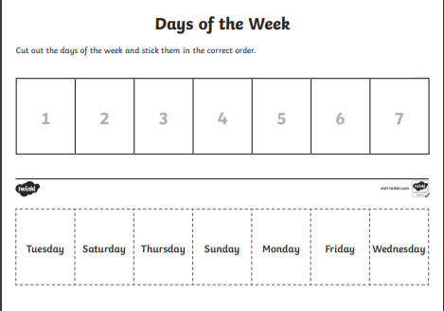 | Maths  Write numbers on between 10-20.  Months of the year https://www.youtube.com/watch?v=Fe9bnYRzFvkJoin  Can you repeat the months of the year to your grown up?  What happens in December.  What month is your Birthday?  How many months in a year?  https://www.youtube.com/watch?v=X6cAi0ydAyc | Maths  Practice counting in 5s to 25.  Using a kitchen clock can you point out the big hand and the little hand. What does the big hand tell us and what does the little hand tell us?  Beat the clock, have a guess at how many actions such as jumps, hops etc you can do in a minute. See if you are right.  How many seconds are in a minute? | Maths  Order the numbers from 1-20  Can you make a paper watch and make the time say 5 o’clock. Remember to add a big hand and a little hand.  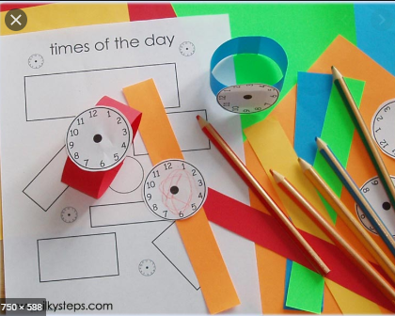
10mins | Literacy  https://www.youtube.com/watch?v=9pRhgZ8Jffs  Show ‘Commotion in the Ocean’. Explain this is a collection of poems; ask children if they know what poetry is. Explain that poetry is a collection of words arranged in patterns of sound and often includes descriptive and rhyming words.  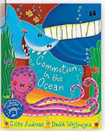 | Literacy  With a grown up reading with. Look at the under the sea power point. Talk about what you have learned and then write down 2 facts. Power Point on blog. | Literacy  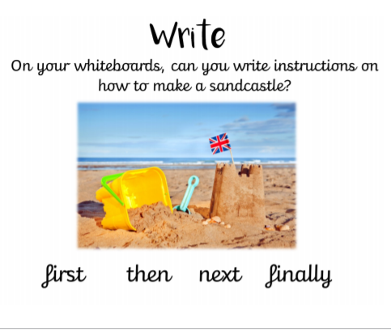 | Literacy  Find the missing letters. See blog | Literacy  Seaside story board See blog.
30mins | Physical exercise of your choice. | Physical exercise of your choice, | Physical exercise of your choice. | Physical exercise of your choice. | Physical exercise of your choice

