Monday | Tuesday | Wednesday |  | Thursday | Friday
Topic  This week we are learning about sea creatures.  See if you can identify, from the clues, which sea creature is being revealed. (see blog power point)  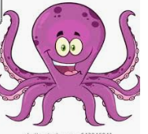 | Wellbeing.  Spot the difference (seaside theme on blog ) |  | Topic  Octopus facts  Can you draw an octopus and write some facts about it?  https://www.youtube.com/watch?v=0u6jV9mkFuY#:~:text=all%20right%20so%20octopuses%20are,did%20you%20know%20an%20octopus. | Wellbeing.  Using recycling materials or old bits of materials around the house design and make a sea creature.  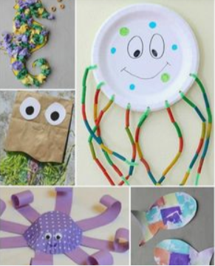 | Topic  sharks  https://www.youtube.com/watch?v=VaRHVd9s3js  tell your grown up what you have learned about sharks.

