**Who is this?**

1. **Look** at each picture. *Do you know the name of this animal?*
2. **Describe** the animal. *What will it feel like, sound like and smell like?*
3. **Write** the name of the animal. *Can you use the wordbank to help you write the name?*

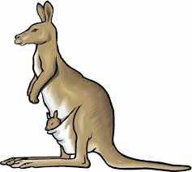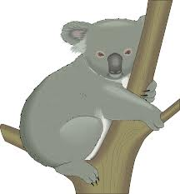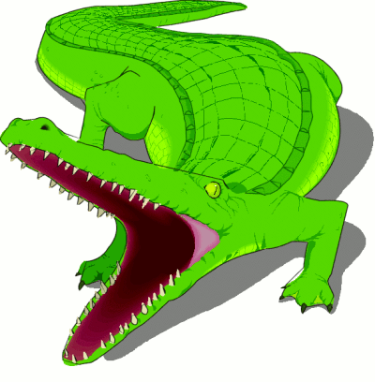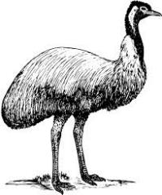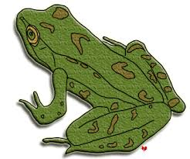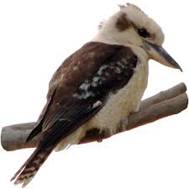

kangaroo crocodile frog

emu koala bear kookaburra

Feeling proud of herself she decided to give fire to people. She flew around the country putting Fire into the heart of every tree. From that day on people could make Fire using dry sticks and logs from a tree.

To this day Crocodile lives down in the swamp. His Fire is gone now. Rainbow Bird still lives in the air and sometimes you can see her taking fire to the trees, in a blaze of feathers rainbow bright.

Then Bird Woman did a dance and put the firesticks into her tail. She became the beautiful Rainbow Bird. She told Crocodile Man that he must stay down in the wet water, while she flew high and dry in the air.

Crocodile Man wouldn’t share the fire with anyone! Bird Woman pleaded with him to let her have fire, but he told her to eat her food raw. She asked about sharing fire with the people, but he said no!

Long ago in the Time of Dreams, there lived a rough, tough Crocodile Man. He was huge and mean and scary. He had fire! He held it with his feet, balanced it on his head and breathed it from his throat.

Time passed. Bird Woman watched Crocodile Man and waited. One afternoon he opened his mouth very wide to yawn and Bird Woman flew down and snatched a firestick, and flew back into the air.