Monday | Tuesday | Wednesday |  | Thursday | Friday
Topic  Talk about what you wear when you visit the beach in the summer time when the weather is warm and sunny. Why is the sun good for us and other living things? Cut out the pictures to dress the girl/boy so they are dressed suitably for the beach. Do they need anything else? E.g. swimsuit, wetsuit, water shoes, snorkle Challenge: Draw/paint a beach scene on a large piece of paper and stick out the person and attach them onto the drawing. You could attach the person onto a lolly stick to use as a puppet.  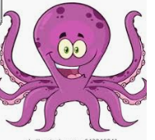 | Wellbeing.  Seaside word search (on the blog).Try to relax, perhaps play some music in the back ground..  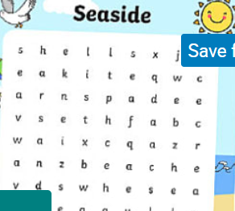 |  | Topic  Talk about children’s own experiences of how to keep safe in the sun. What do you wear and why? Why is it important to apply and re-apply sun cream? Why do we need to cover our heads? Have you ever been hurt by the sun? What did it feel like to be sunburnt? Why is it important to stay hydrated? Draw a picture of yourself and label 3 or more things of how you keep yourself safe in the sun e.g. I wear a hat. I sit in the shade. I put on sun cream. | Wellbeing.  If the weather suits and a grown up is available. Why not go rock pooling and see what you find.  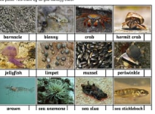 | Topic  Look at the power point telling the story of Sammy the Seagull.(This is on the class blog)Talk about how the children stay safe at the beach e.g. stay with a grown up, go in shallow water. Talk about the force of the waves and the wind and how it can be very dangerous to go in the water without an adult. Talk about the meaning of the flags and the windsock. Would it be safe to go in the sea if it is very windy? Why not? Draw then paint your own flags to show different messages. Challenge: Can you create your own windsock for your garden or outside area? What material could you use?

