 |  |  |  |  |  |  |  | Year 2 Home Learning
 |  |  |  |  |  | Week Commencing 13th July 2020
 | Reading |  | Read the fact sheet about Emus. Underline 4 words that you do not know the
 |  |  | meaning of or think other children would find hard to understand. Ask an
 |  |  |  |  | adult or use a dictionary to find out the meaning of those words.
 |  |  |  | https://www.collinsdictionary.com/dictionary/english Complete the dictionary
 |  |  |  |  |  |  |  |  | detectives sheet for your 4 words.
 |  |  |  |  |  | Gold – Create your own true or false questions about emus.
 | Writing |  |  |  |  |  |  |  | Listen to the story Edward the Emu
 |  |  |  |  |  |  |  |  | https://www.youtube.com/watch?v=Ny73lql8PRE.
 |  |  | Cut out and order the story. See if you can rewrite the story in your
 |  |  | neatest handwriting and add an expanded noun phrase to each sentence.
 |  |  | If you really want to challenge yourself see if you can add an adverb too.
 |  |  | Then, create your own Edward the Emu word search for someone at
 |  |  | home.
 |  |  | Gold – Make your own Edward the Emu and use him to retell the story. Try
 |  |  |  | and use expression when your speaking to show how Edward is feeling
 |  |  |  |  |  |  |  |  |  | throughout the story.
 |  |  | Complete week 11 and 12 from Whiterose. Worksheets are on the blog. |  |  |  |  |  |  | .
 | Maths
 |  |  |  |  |  | Gold - Complete the money activities included in this week’s home learning pack.
 | PE |  |  |  |  | Have a go at some of the activities on the superhero dance
 |  |  |  |  |  |  | sheet. Gold – https://www.youtube.com/watch?v=gCzgc_RelBA
 |  |  |  |  |  |  |  |  | Have a go at the Waka Waka dance.
 | Science |  |  |  |  |  |  |  |  | Watch this video -
 |  |  |  |  |  |  | https://www.bbc.co.uk/bitesize/clips/z7x76sg Can you complete
 |  |  |  |  |  |  |  |  |  | the camouflage experiment?
 |  |  |  |  |  |  |  |  | Gold – Design a camouflage superhero.
 | Art/DT |  | Can you re-create the picture from the book “Why I Love Australia”. Use
 |  |  | your imagination to think about how you could create all the different shapes.
 |  |  |  |  |  |  | You might want to use things like potatoes or leaves.
 |  |  | We would love to see your creations so if you create anything please send it
 |  |  |  |  |  |  |  |  | through to us using Class Dojo
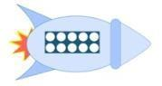
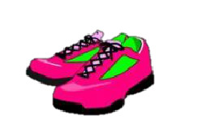

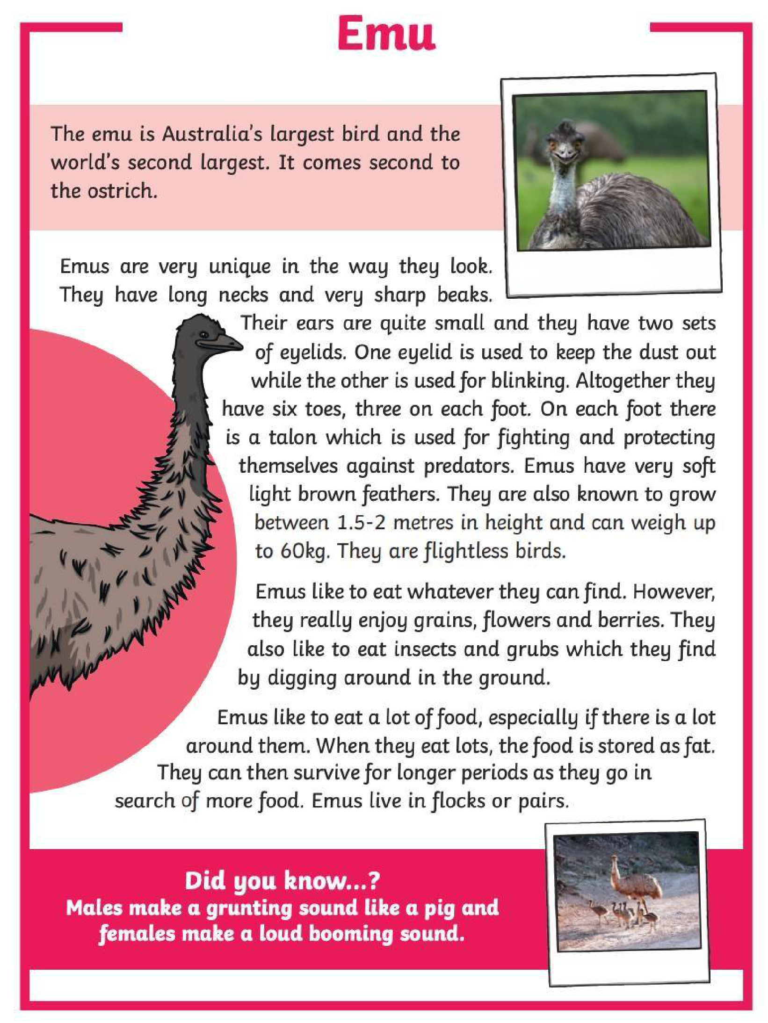

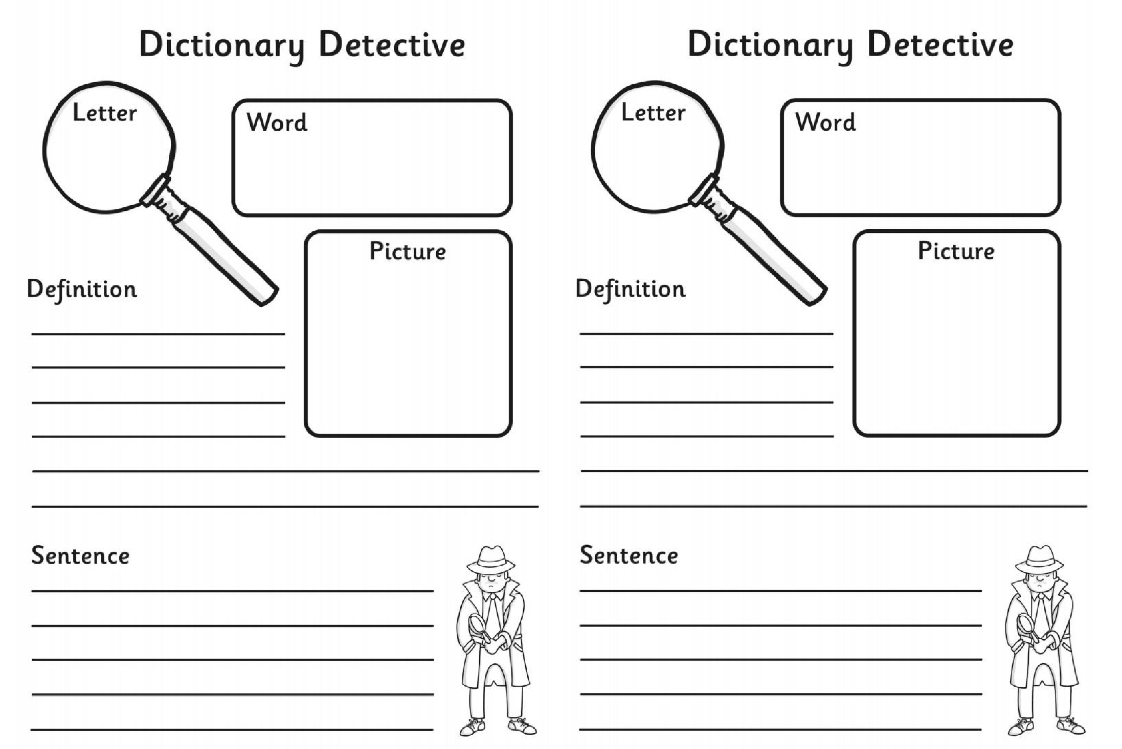

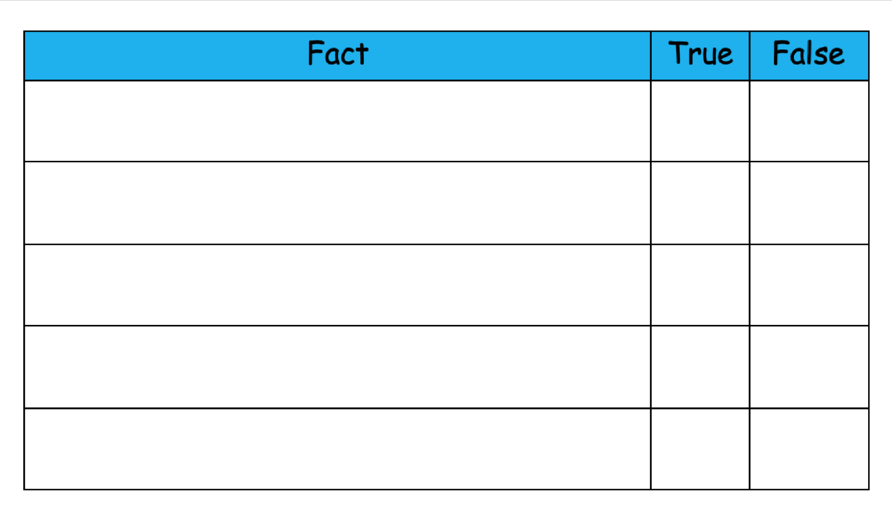

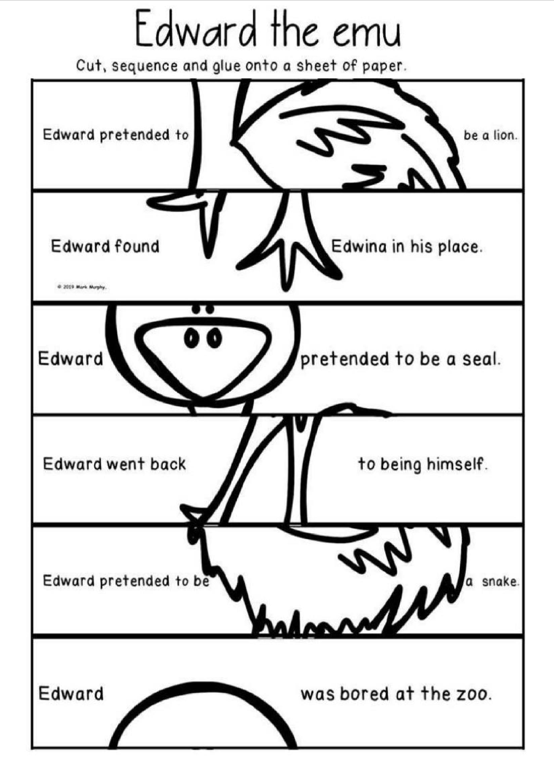

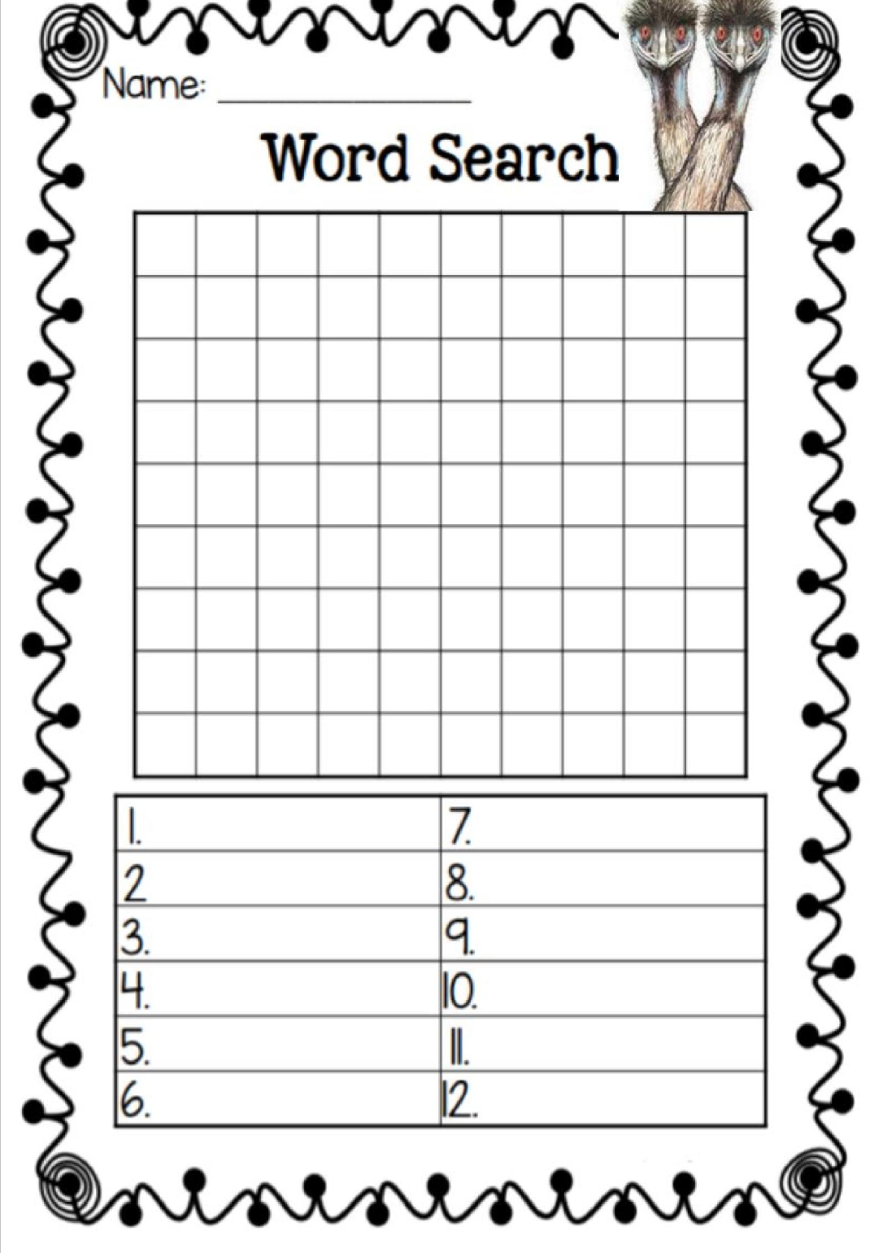

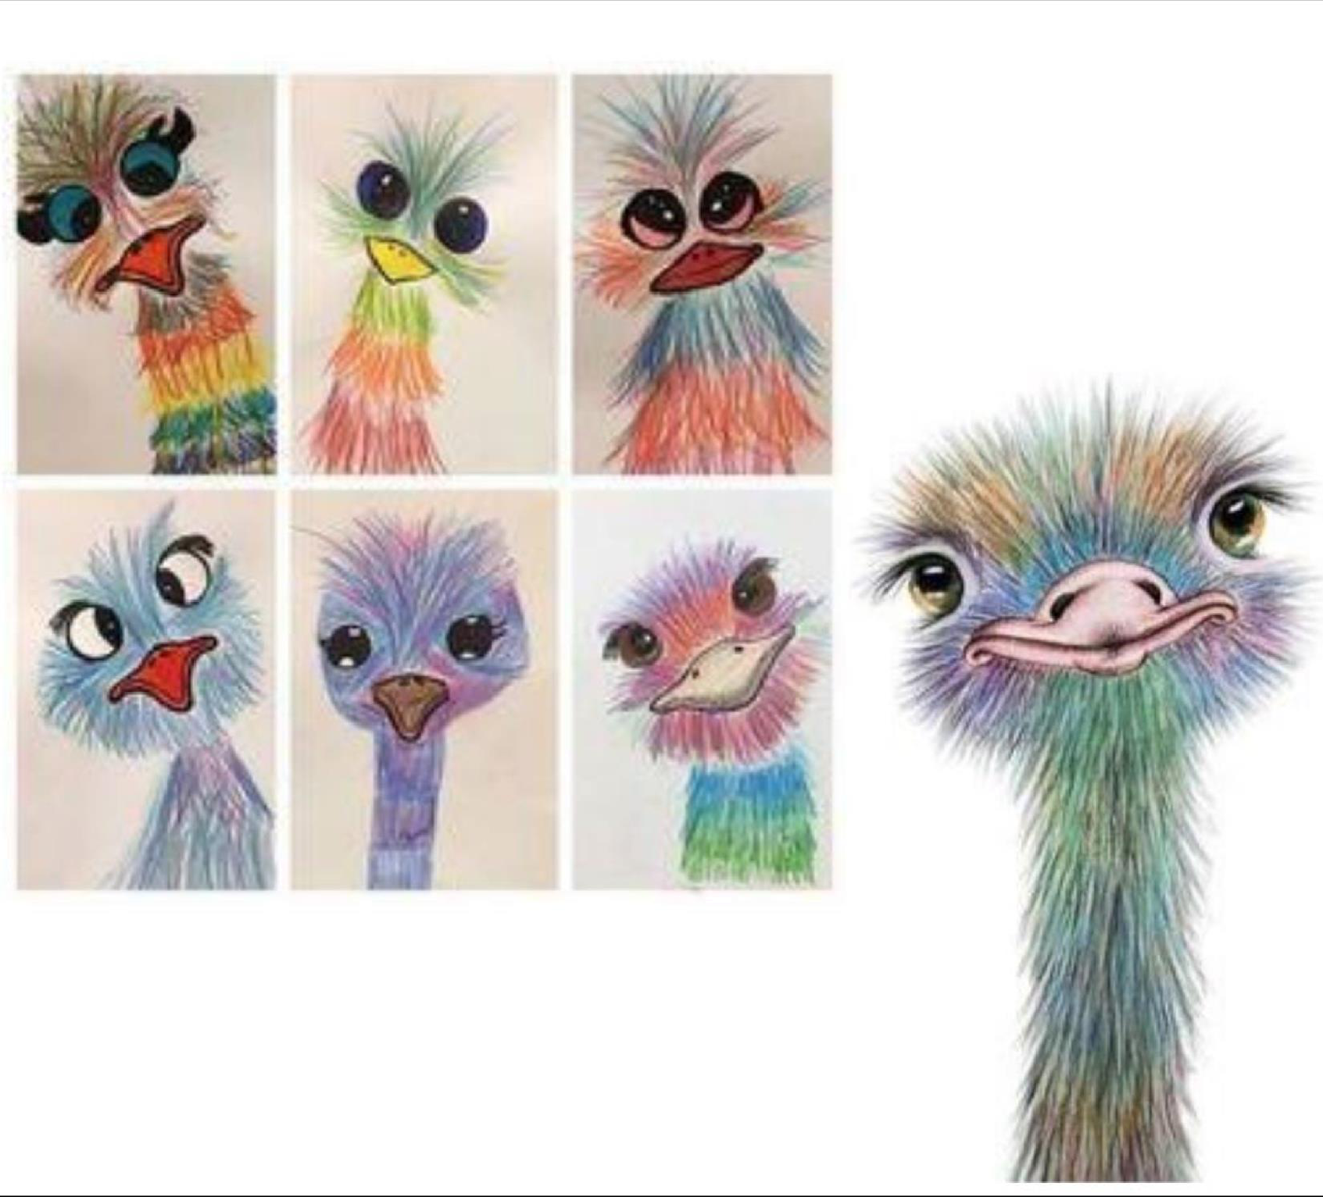

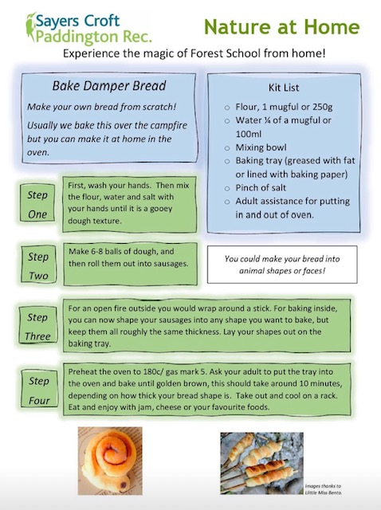
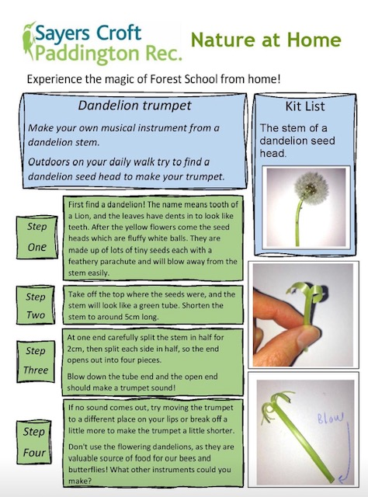
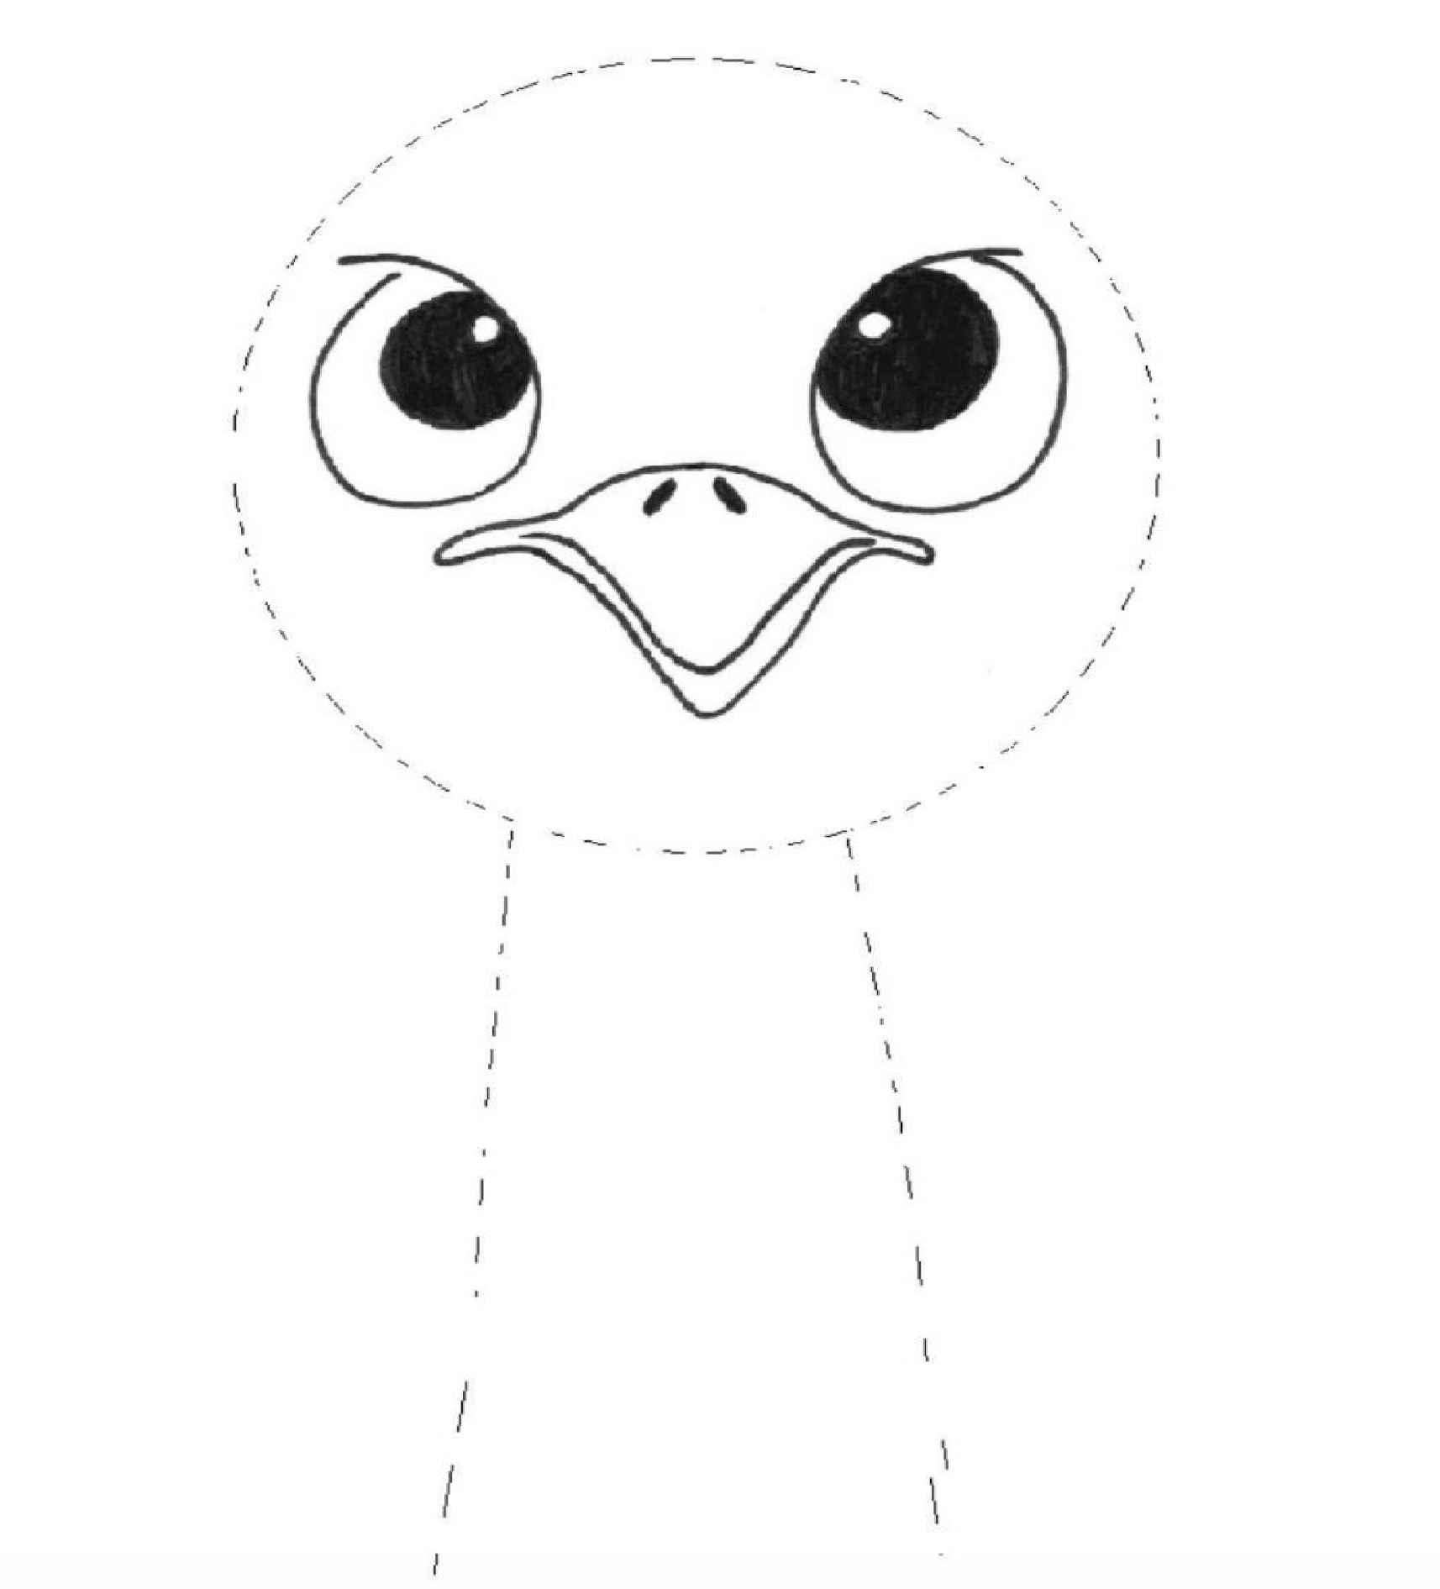

Edward the Emu text
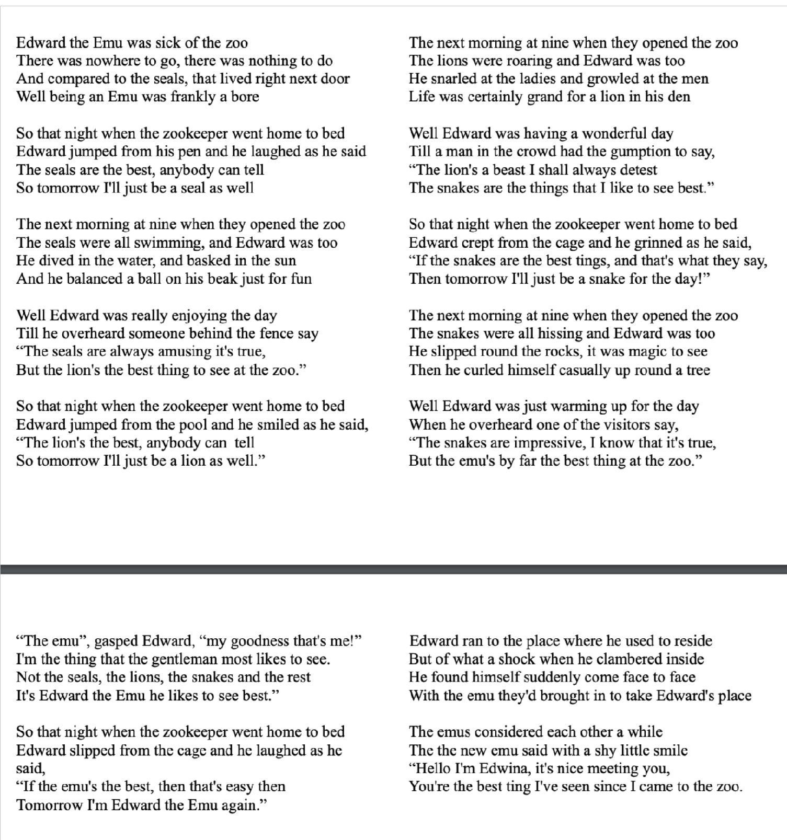

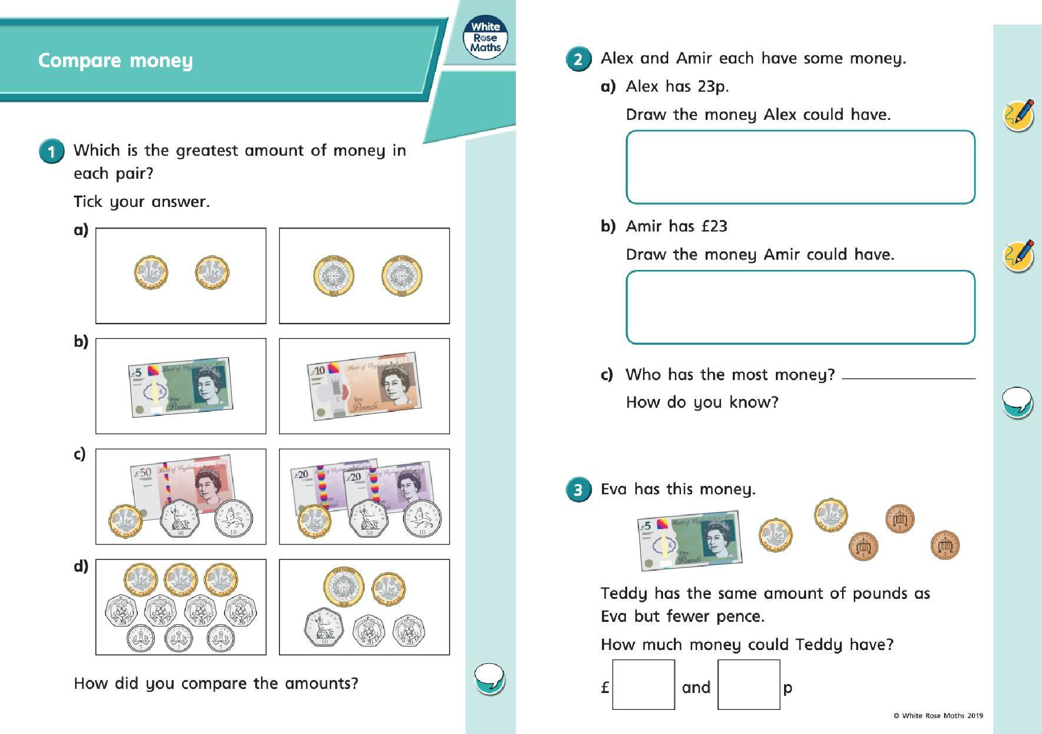

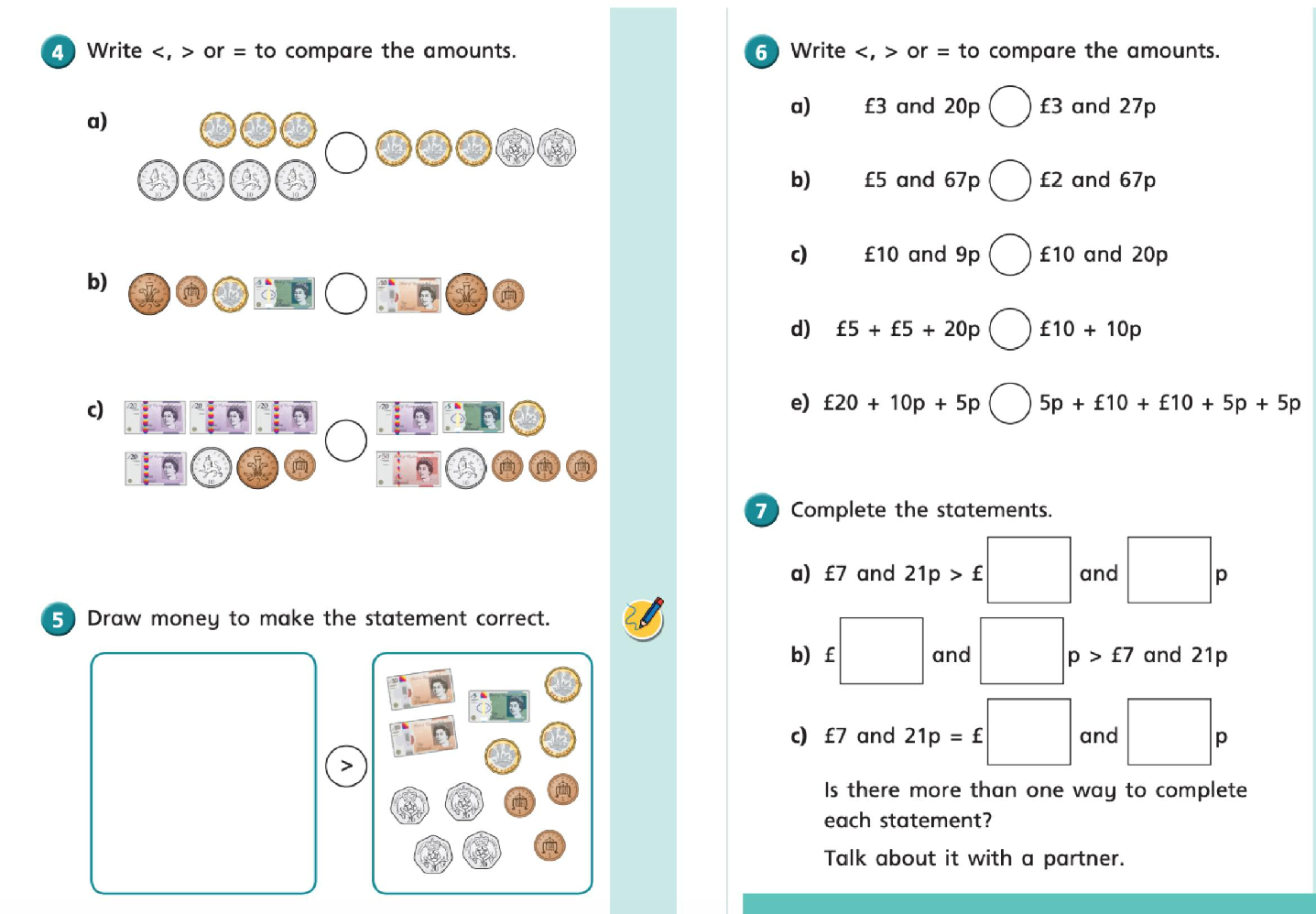

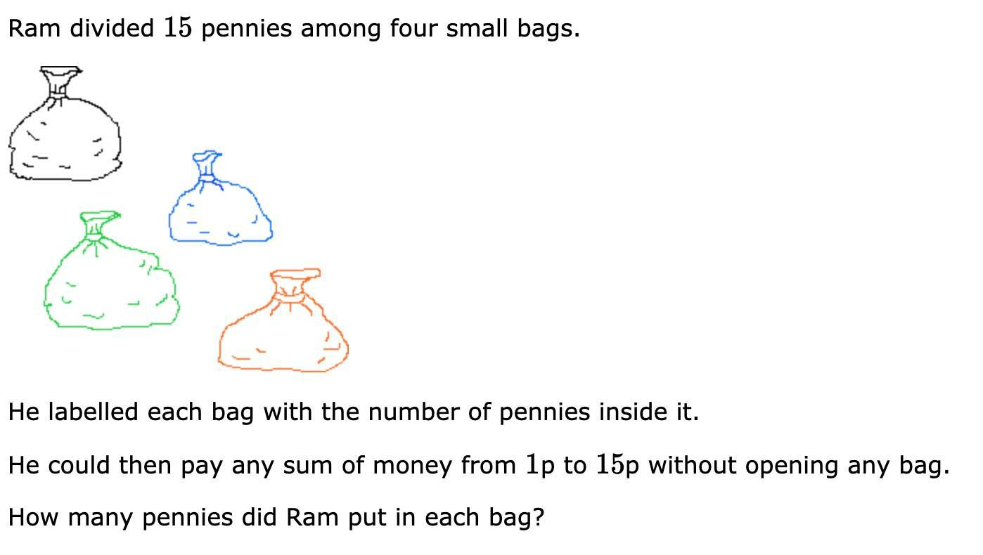

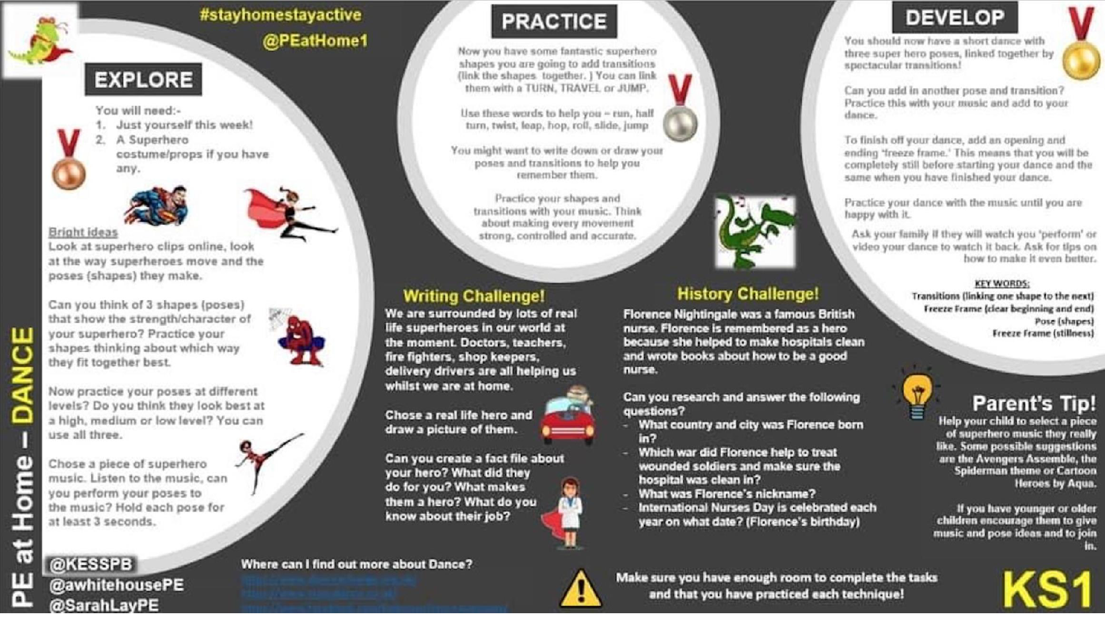

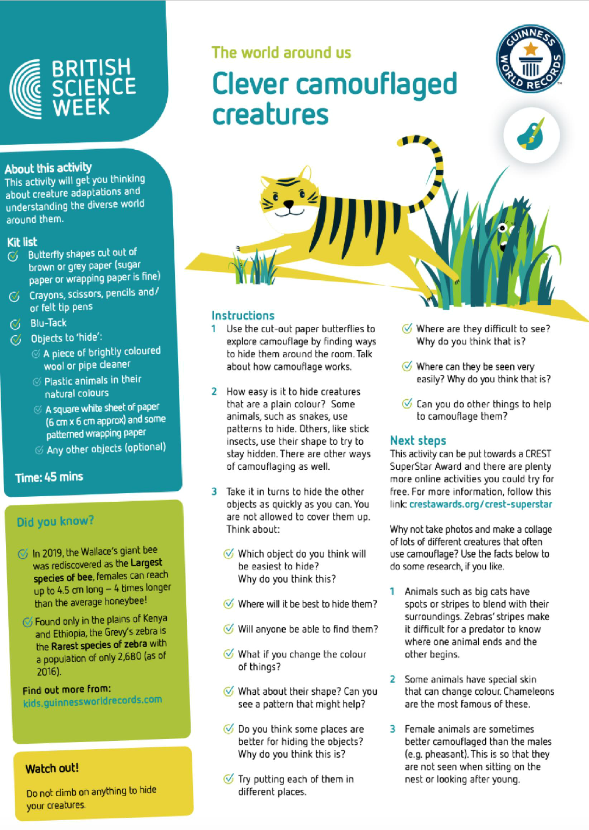

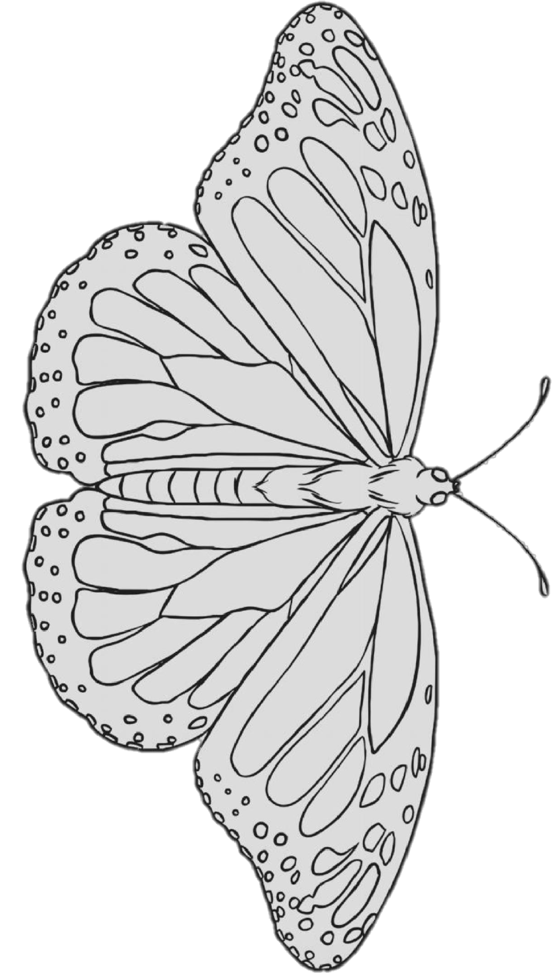

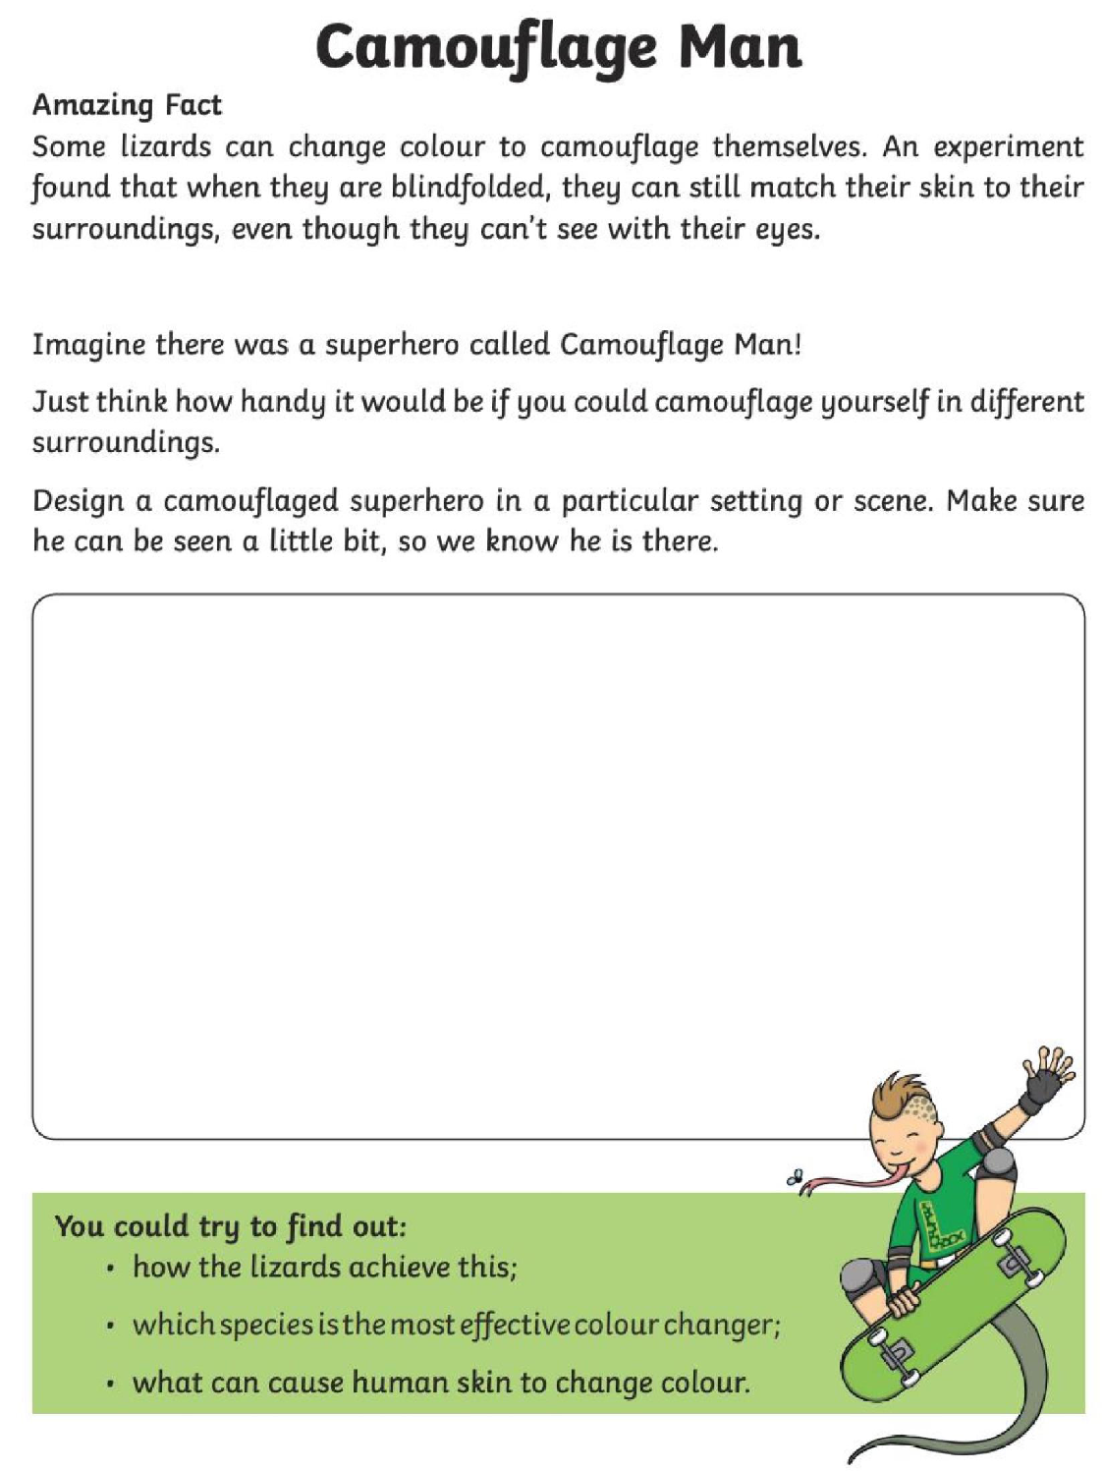

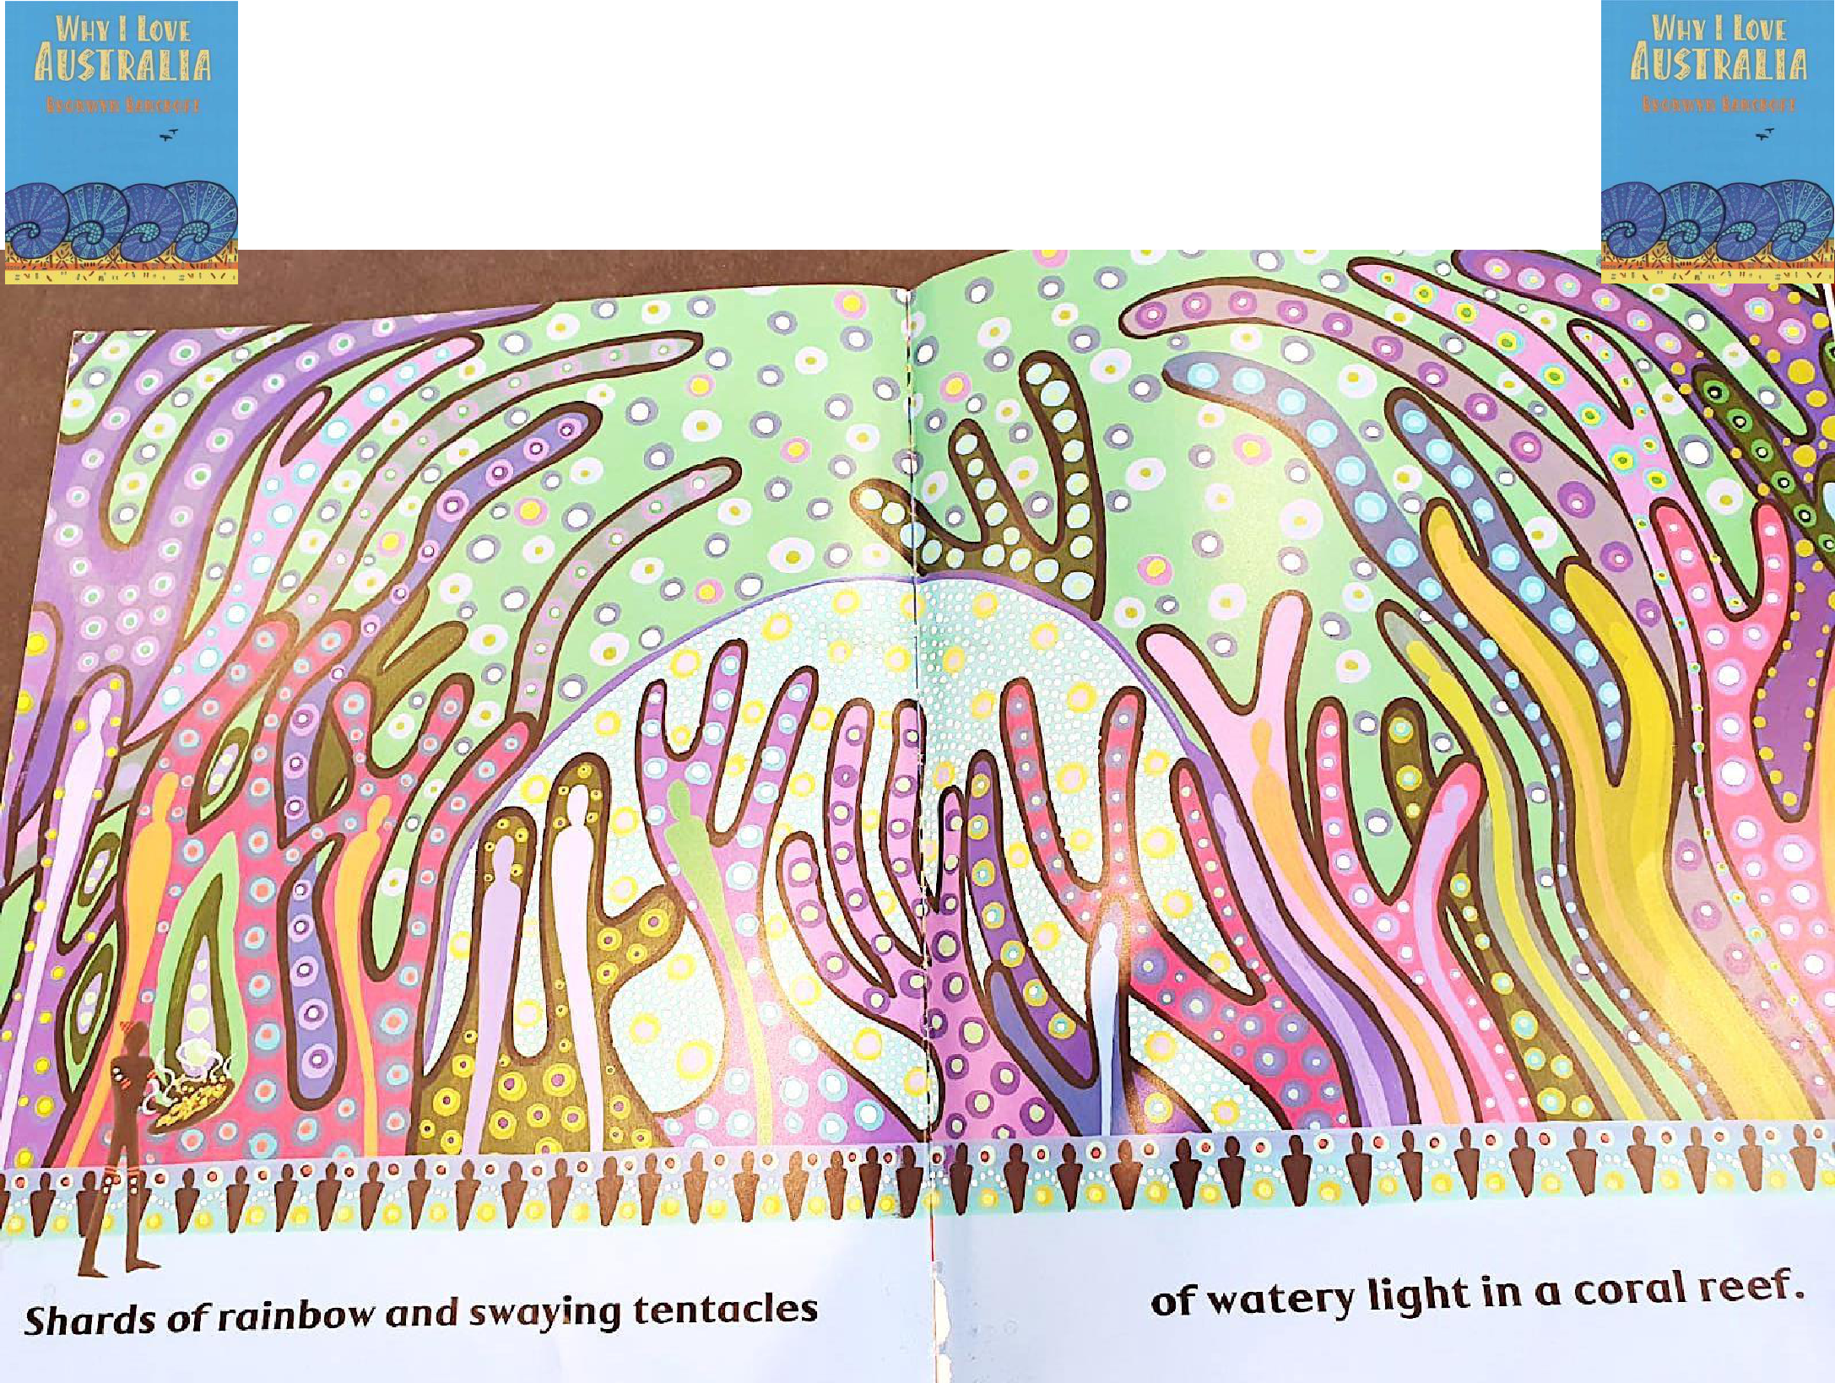
Why I Love Australia Art

