Monday | Tuesday | Wednesday |  | Thursday | Friday
Topic  Look at the power point on the blog.  What was similar about all of the different beaches?  What was different about some beaches compared to ones you go to?  What was your favourite beach? Why? How would you get to these beaches?  Do beaches look the same all year round?  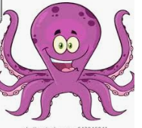 | Wellbeing.  Find an empty container with a lid. Write down 2 things that make you happy and put them in your container.  Ask your adult, what makes them happy.  Chill and go for a walk or watch a movie or cartoon. |  | Topic  Why is the sea salty?  https://www.youtube.com/watch?v=1qbUUGguJjE | Wellbeing.  Write another 2 things that make you happy and add them to your container.  Today, why not take some time out. Go for a walk, listen to music or perhaps using hand cream (with your adult’s permission) you could give each other a hand massage. | Topic  What are Oceans of the world?  https://www.youtube.com/watch?v=j9elm85IBYA  How many oceans do we have?  Can you name 2 Oceans?  What shape is the earth?  