Home Learning – Thursday 16th July
English
Start with a reciting the On the Ning Nang Nong poem with actions/body percussion. Listen to Brian Moses’ Walking with my Iguana at
http://childrenspoetryarchive.org/poem/walking-my-iguana. Can you hear the rhythm in this reading? Listen again and try to join in with rhythm. Why do you think the poet chose to read his poem with such a strong rhythmic feel? Is it the walking pace? What images are called to mind when you listen to this poem? Are there any humorous bits? Jot down your thoughts on the poem if you wish. Which was your favourite part of the poem?
Spot the rhyming couplets and different spelling patterns of the ea/ee sound. Have a go at writing down as many other rhyming words with the same sound.
Have a go at writing your own version of this poem following the same patter, what could you be walking?
Don’t forget to send us any poems that you have written!
Phonics – See attachment
Maths
Recap yesterday’s learning on mass, can you accurately weigh objects?
Today we are going to be talking about length and height.
Discuss what height and weight mean. Have a go with some different height things at home (it could also include different people at home, can you dicsuss who is taller and shoter. You might also think about pencils, one that has been used lots and sharpened would be shorter etc. Go through the power point on height and length, you may want to skip the distance bit or include as an extra. Use lots of different examples using things that you have around the house.
Complete the attached sheet. Extension, can you use a ruler and have a go at measuring the objects in your house. Think about what units we use when measuring things and which would be most appropriate.
Geography
WHAT IS IT LIKE TO LIVE IN A RAINFOREST?
To start off with imagine being somewhere hot, damp and noisy with animal sounds (they may want to think about the biomes at Eden, they just don’t have the animal sounds, or the rainforest section at the zoo. You might like to listen to some music too:
https://www.youtube.com/watch?v=Jorjx1_Dk7A&feature=youtu.be
What animals might you hear, and what sounds might they be making? Imagine the types of flying small bugs and creatures too! Have ever been to a rainforest? Explain that some places in the world are very remote, look at Brazil on a map. It is in South America, and here you will find a very large rainforest – the Amazon rainforest and a very long river running through it – the Amazon River (we learnt about this river a couple of weeks ago, can you remember any facts?). The area covered by the river and rainforest is called the Amazon Basin, and lots of people live here, in towns as well as busy cities. Some other people live very separated lives in remote places of the rainforest. There are many groups of people living in the Amazon basin and Amazon rainforest who are incredibly far away and cut off from the rest of the world – they haven’t got technology like computers, mobile phones or even TV! Explain other things that they may not have access to by using the various sites on the Amazon listed on the useful website links page to discuss living in the Amazon further.
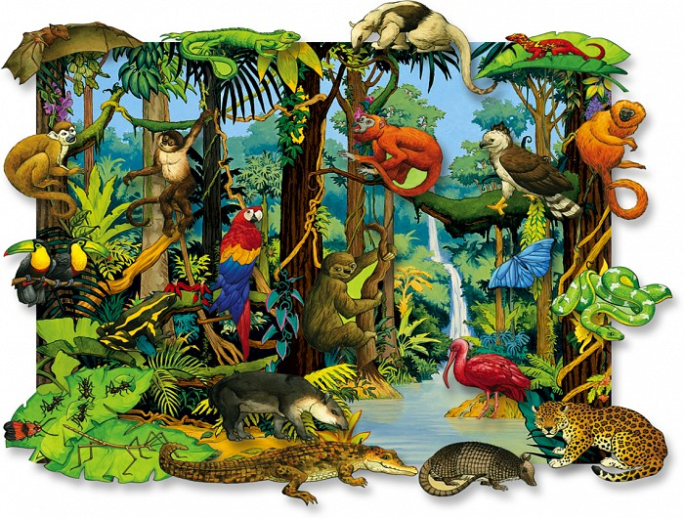
Here are some animals you may find:

Here is a list of animals you may find in the rainforest:
https://www.activewild.com/rainforest-animals-list/
See the photo of people who live remote lives, deep in the Amazon, and who live the same way that their ancestors did http://assets.survivalinternational.org/pictures/1007/braz-yano-fw-32_screen.jpg The Amazon basin is an area that is actually bigger than our country! In fact, it spreads across nine countries all together! For more information, see her: http://news.bbc.co.uk/1/hi/world/americas/7360258.stm Think about the excitement (and problems) of living outdoors. What if you were not near a road or shops?
How are rainforests different to forests that we find in the UK? (Trees do not lose their leaves in the Amazon rainforest. The weather can be hot and sometimes wet all year round in the Amazon.) From the UK, we would have to get in a plane to find the nearest large, natural rainforest! Watch the video A postcard from the Amazon rainforest https://vimeo.com/81934508 Ask: What animals can you see? Discuss what it would be like to live in a house in the trees. What are the houses made of and where are the materials from? How is it different from our houses?

Design a postcard to show aspects of life along the Amazon River. Imagine that you are writing your postcard from the Amazon to a friend.
Have a lovely day,
Miss Adams and Miss Hughes 😊

