EYFS Home Learning 20th July 2020
Literacy: Reflect on your year in school. What can you do now that you couldn’t in September? What was your most enjoyable day? Why? What do I want to get better at? Complete the butterfly sheet with information about what I like and what do I want to get better at.
Creative activity: Using your own choice of materials, paint or draw a picture of yourself for your new teacher. (If you are at home you could bring it to them in September) Write a sentence to tell them something about yourself. Challenge: Write a letter to your new teacher
Maths: Set up an ice-cream shop. Add labels onto the different flavour ice-creams. Using 1p coins, practice paying for the different items. Complete the sheet to see how much each ice-cream costs. Challenge: Draw your own/make your own ice-creams and add your own prices.

EYFS Home Learning 21st July 2020
Literacy: What are you looking forward to about joining Year 1? Talk about how children are feeling about the new classes. What are you nervous about? What are you excited about? Which friends are you excited to see? Complete ‘My wish for Year 1’ star.
Maths: Look at the picture below of the fruit shop and create your own. What are the prices of the fruit? Do they cost the same, more or less? Count the coins and practice counting out the correct amount of coins. Do you have enough to buy two pieces of fruit? Borrow some more 1p coins and add more pieces of fruit. How much do they cost? Practice counting out 1p coins to buy different amounts. Challenge: What if you used 2p coins?

Count the coins and write the price of the ice-creams.
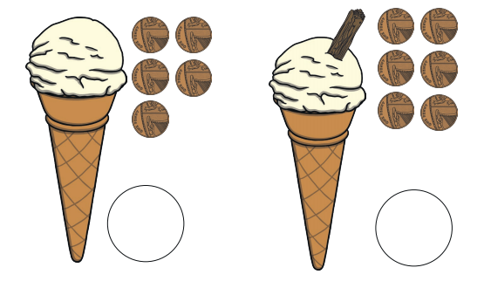
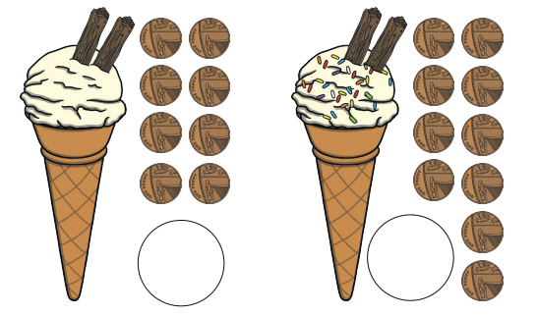

Fruit shop Maths
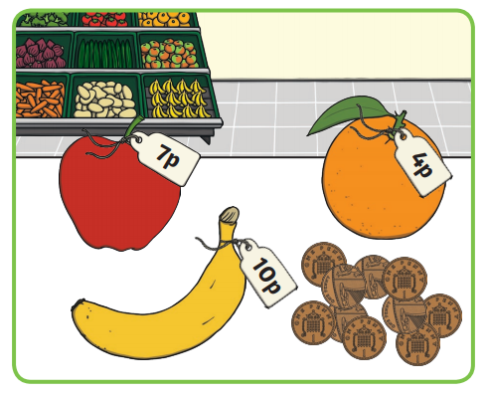
What are the prices of the fruit? Do they cost the same, more or less?
Count the coins and practice counting out the correct amount of coins. Do you have enough to buy two pieces of fruit?
Borrow some more 1p coins and add more pieces of fruit. How much do the cost?
Practice counting out 1p coins to buy different amounts.
Challenge: What if you used 2p coins?

