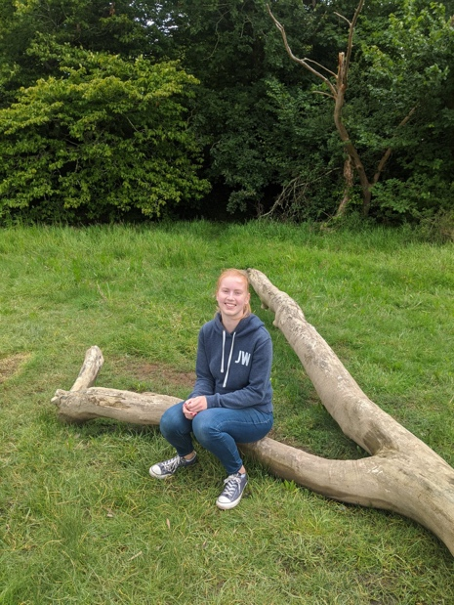
Hello everyone,
My name is Miss Wright – I know some of you already because you were in my class last year and I hope I’ll get to know the rest of you very well soon!
In September, I will be a Year 4/5 teacher and I will also be organising some P.E. activities.
The school value that means the most to me is curiosity. If everyone approached every question or challenge in school with curiosity, I think they would be surprised by what they can achieve. I think that sounds like a very good environment to be in.
One of my favourite series of books is the Harry Potter series by J. K. Rowling because it teaches us to be courageous in the face of adversity. It also teaches us to stand up for others and do what is right. My favourite character is Hermione as she works hard to achieve her goals.
In my spare time, I enjoy walking, martial arts, watching Leicester City football games, eating pizza and travelling to new places. I am lucky enough to have spent time living in Germany, Austria and Chile as well.
My personal role model is my dad because he helps others and tries to make the world a better place. His job entails helping the environment and so I believe in only taking what you need and being thoughtful about your actions. Hopefully we can explore the environment more next year.
Did you know that… the amount of water on Earth is constant, and continually recycled over time so some of the water you drink today will have been drunk by a dinosaur. Did you also know that recycling one aluminium can is able to save enough energy to run a TV for 3 hours?
I can’t wait until September when we can find out lots more interesting facts and perhaps you could teach me some fascinating things too!

