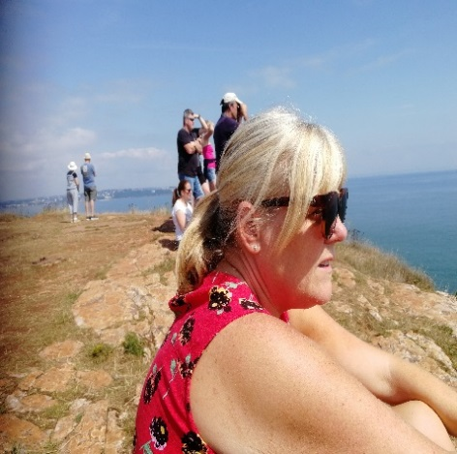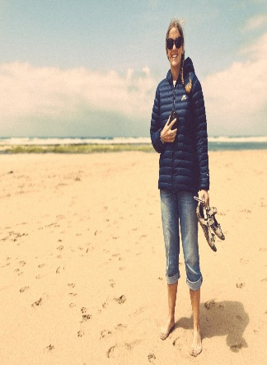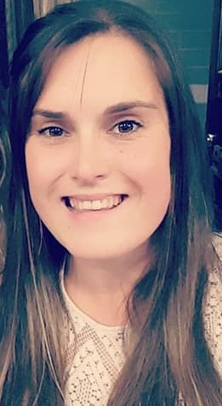

Miss Whitty -,Teaching Assistant

Miss Whitty’s favourite things are: Walking my dogs, riding horses and seeing my friends.

Miss Whitty’s favourite book is: I enjoy all the books you want to share!

Miss Whitty’s favourite activities are: Phonics, forest school, reading with you all and JUST DANCE I know most of you enjoy this too!

Miss Whitty can’t wait to see you all again and see you all grown up in your new RED uniform. For those of you who I don’t know I can’t wait to meet you!

Miss Ward - Teaching Assistant

Miss Ward’s favourite things are: reading, gardening and nature.

Miss Ward’s favourite book is: The Secret Garden.

Miss Ward’s favourite activities are: sharing books and forest school.

Miss Ward can’t wait to meet you all as soon as possible.

Mrs Hillyard HLTA Teaching Assistant

Mrs Hillyard’s favourite things are: going to the beach, walking and drawing.

Mrs Hillyard’s favourite book is: Harry Potter

Mrs Hillyard’s favourite activities are: art, craft and reading.

Mrs Hillyard can’t wait to meet everyone, and is looking forward to meeting those of you that I don’t already know and helping you to learn.

Mrs Rudd- Class Teacher

Mrs Rudd’s favourite things are: walking my dog Shadow, running, exploring the beach and being sociable.

Mrs Rudd’s’ favourite book is: little rabbit Foo Foo. I just love the actions that go with this story.

Mrs Rudd’s favourite activities are: reading stories, phonics and learning through play.

Mrs Rudd can’t wait to meet everyone and start our fun filled adventure together.

Welcome to Reception 20/21

We can’t wait to meet you!

In the meantime, here’s some information about us so that you can get to know all about your new adults before you start school.