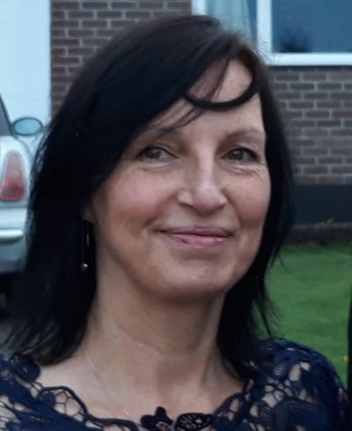 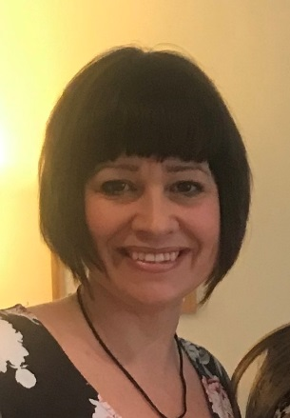

Mrs Thomas Teaching Assistant

Mrs Thomas favourite things are. Spending time with my family and friends, Walking my dogs Monty and Harrison through the fields to Sibbly Back Lake and walking on the Moors and riding my bike.

Mrs Thomas favourite book is: Guess How Much I Love You, it was a book I read to my children that is special to us.

Mrs Thomas favourite activities are: hearing the children reading, guided writing, phonics and support when writing their own sentences.

Mrs Thomas can’t wait to meet you all and get to know you and the great fun we will have and listen to all the exciting things you want to tell us at school.

Miss Ronald - Pre School teacher

My favourite things are: watching films, cooking and seeing my friends!

My favourite book is: I love all of the Julia Donaldson books.

My favourite activities are: reading stories, imaginary play and singing songs 😊

I Can’t wait to meet you all and have lots of fun together!

Mrs Prout - Teaching Assistant

Mrs Prout’s favourite things are: reading and visiting new places with my family.

Mrs Prout’s favourite book is: We’re going on a bear hunt.

Mrs Prout’s favourite activities are: arts and craft and role play.

Mrs Prout can’t wait to meet you all, help you settle in and meet new friends.

Welcome to Reception and Pre School 20/21

We can’t wait to meet you!

In the meantime, here’s some information about us so that you can get to know all about your new adults before you start school.