Reception Newsletter

Friday 11th September 2020

Optional Home Work.

As we teach the children to write letters and numbers, we are also focusing on how the children hold a pencil. It is essential that we get this correct early on, as it can be tricky to change if bad habits are learnt. If your child is **choosing** to write, draw or colour at home, please show them how to hold their pencil correctly.

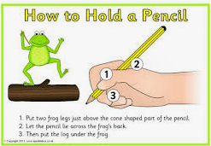It is also important that your child begins to become more independent by allowing them to carry out small tasks. These can include things like dressing and undressing themselves, carrying their book bags and water bottles into school, hanging up their coats, putting their book bags in the right basket and putting their name cards on the correct lunch choice.

Learning

This week we be learning to read and write the letter sounds m,a,s. We will also be finding objects that begin with these sounds around the school.

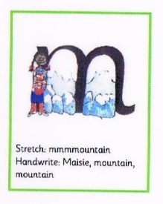 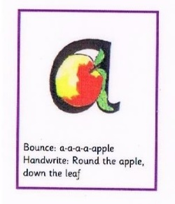 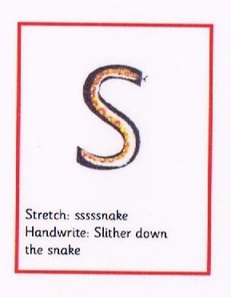

We will be reading lots of stories that follow the theme of Personal, Social and Emotional behaviours in order to continue developing relationships and friendships.

In maths we will be counting objects, by pointing carefully and counting slowly.

We are looking forward to hearing the children read and ask parents to support reading at home by listening to the children at least 3 times per week.

.

PLEASE read at home as often as possible but at least 3 or 4 times a week**.** C:\Users\ciaramoran\AppData\Local\Microsoft\Windows\Temporary Internet Files\Content.IE5\5JV43MRH\MC900440424[1].wmf

**We just wanted to say a huge thank you for helping the children settle into school. The children have looked really smart in their school uniform and we look forward to developing our working relationship with you.**

**Reminders:**

We would really like for Tapestry to be a joint learning journey shared between teachers and parents to record your child’s first year at school. It would be interesting to see what they have been doing at home. So please have ago at sharing a photo and a little something about what they were doing. It might be a sporting activity or something such as mark making on the beach. If you have any problems activating your Tapestry account, please see a member of staff.

**Remember to come to school daily with your reading book bag containing your reading book and reading record. Plus, your water bottle. We provide a daily snack and milk/water and ensure the children do get a drink at school. We ask for water bottles, so the children have further opportunities to drink, which we encourage.**

Diary DatesWe are so pleased with how well the children have settled into school on their first day. We have been busily learning new routines, meeting new friends and having lots of fun learning through play, both inside and outside the classroom. It’s lovely to see the children coming into the classroom in the morning and accessing the learning opportunities set up; they will be gaining more confidence each day!.