Pre School Newsletter

Monday 21st September 2020

Learning

This week we be counting numbers 1-5 in particular finding out if we can recognise them and use our fingers to form the numbers. Last week we sang ‘5 little monkeys jumping on the bed’ to help with our counting. You can find this on the bbc nursery rhymes website.

This week our topic is Autumn. What signs of Autumn can you spot while out and about? (crunchy leaves etc)

Marvellous Me:

We would like to complete a family tree display for our classroom which links to our topic of ‘marvellous me’. Please upload a family photo we can use on Tapestry. 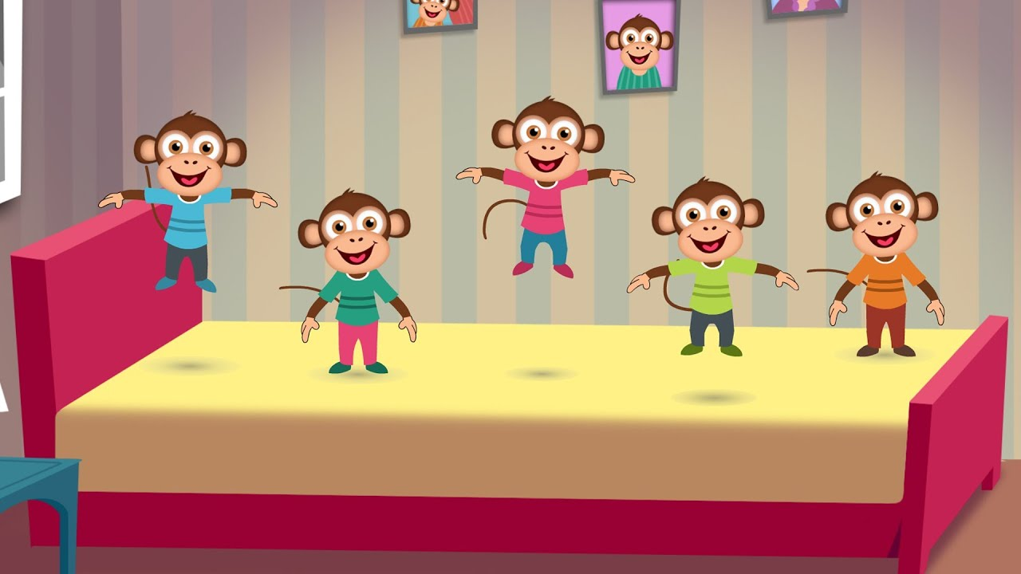

PLEASE read at home as often as possible but at least 3 or 4 times a week**.** C:\Users\ciaramoran\AppData\Local\Microsoft\Windows\Temporary Internet Files\Content.IE5\5JV43MRH\MC900440424[1].wmf

Optional Home Work.

Some topics we will be looking at this week:

Scissor Skills

This week we will be supporting the children to use scissors. It would be great if they could also practice this at home. (cutting paper, grass etc)

Fine Motor

We will be focusing lots on fine motor skills and this week we will be using pegs, threading and using scissors. Could you help peg the washing out at home or thread some beads?

 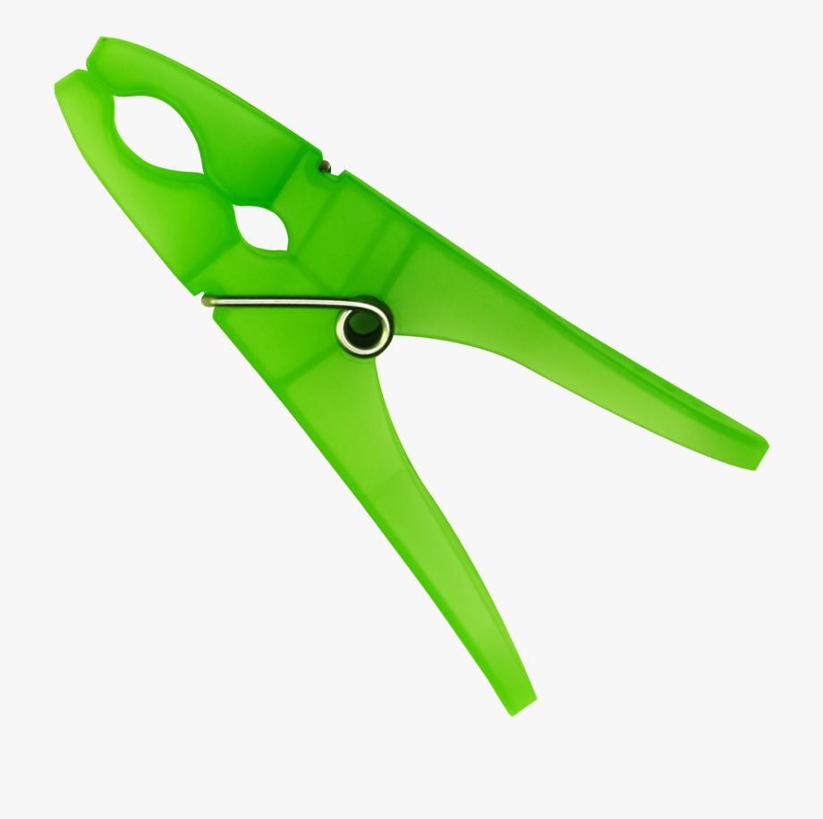

**Reminders:**

Last week we had an African Land Snail join the reception class as their new pet. The children have named him Timmy. I would love to know if you have any pets at home. Please upload a photo to Tapestry.

We would really like for Tapestry to be a joint learning journey shared between teachers and parents to record your child’s first year at school. It would be interesting to see what they have been doing at home. So please have ago at sharing a photo and a little something about what they were doing. It might be a sporting activity or something such as mark making on the beach.

Thank you for your continued support. If you have any questions please ask a member of the Pre School team. 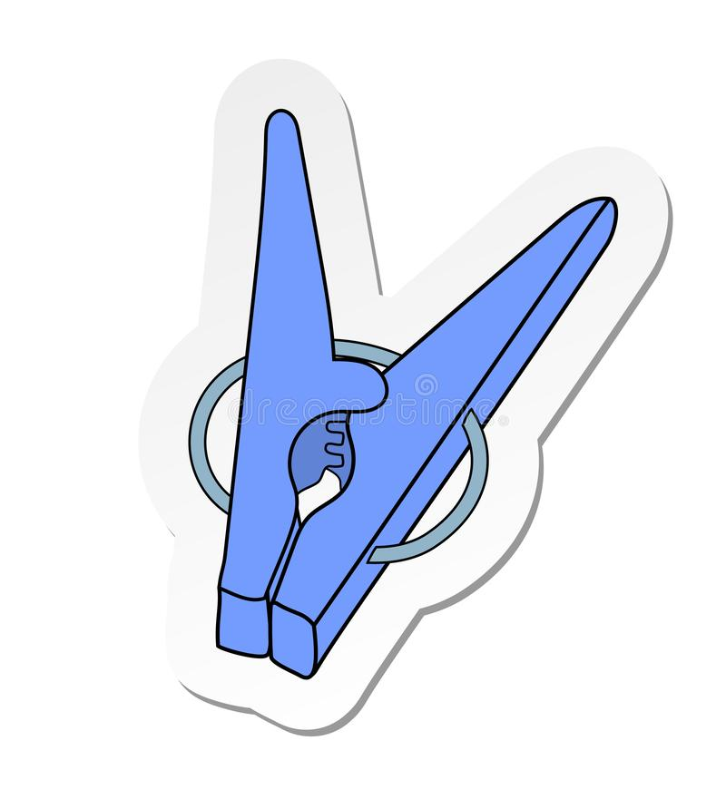

Diary dates

School closes on Friday 23rd October at 3.15pmSchool returns Tuesday 3rd November.

School closes Friday 18th December for Christmas.