Reception Newsletter

Monday 28th September 2020

Learning

This week we will be learning to sound and write the letter sounds i n and p.

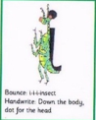 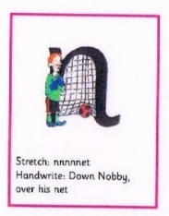 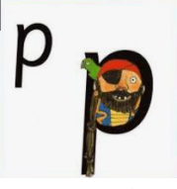

In maths this week we will be sorting a variety of objects according to their properties.

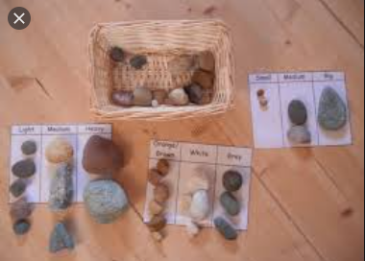

PLEASE read at home as often as possible but at least 3 or 4 times a week**.** C:\Users\ciaramoran\AppData\Local\Microsoft\Windows\Temporary Internet Files\Content.IE5\5JV43MRH\MC900440424[1].wmf

Optional Home Work.

It is always beneficial to read with your child 3 times per week.

Try to practise writing this week’s letter sounds. You could even see how many words you can think of that begin with this letter sound. 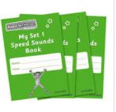 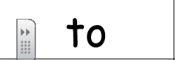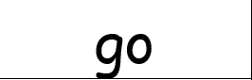

Autumn is upon us and we will be celebrating Harvest this week and looking at changes. We would like the children to go for a walk with a grown up and look for signs of Autumn. You could draw a picture or collect items to display in the class.

If anyone else is collecting your child, please let us know in the morning.

Star Celebrations: All the children have been stars but we would particularly like to say well done to Edie for her concentration and commitment in forming her letters correctly.                

**Reminders:**

Please visit the classroom blog as I am aware that I am printing Newsletters that can be obtained through the blog and this is more environmentally friendly. I have put a video on the blog of a simple phonics lesson, which I hope will give you an idea of what a phonics lesson looks like.

Just another request, please name your child’s clothing so that we can make sure to return items to the correct person.

Drinking bottles should be **filled with water**. If your child has a medical issue, we are happy to discuss this further.

Diary dates

School closes on Friday 23rd October at 12.30.

School returns Tuesday 3rd November.

School closes Friday 18th December for Christmas.

