Reception Newsletter

Monday 5th October 2020

Learning

This week we will be learning to sound and write the letter sounds o c and k.

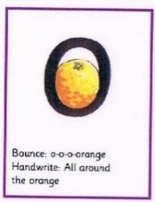 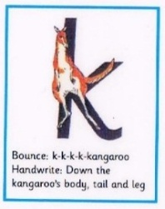 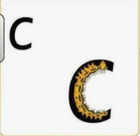

In maths this week we will continue with sorting whilst comparing amounts and size.

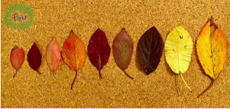

PLEASE read at home as often as possible but at least 3 or 4 times a week**.** C:\Users\ciaramoran\AppData\Local\Microsoft\Windows\Temporary Internet Files\Content.IE5\5JV43MRH\MC900440424[1].wmf

Optional Home Work.

It is always beneficial to read with your child 3 times per week. Please can you ensure that you record reading in your child’s reading record book so that we can monitor how often they are reading.

Try to practise writing this week’s letter sounds. You could even see how many words you can think of that begin with this letter sound. 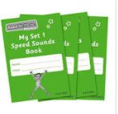

Our red words this week are:

into me she

If anyone else is collecting your child, please let us know in the morning.

Star Celebrations: Carmen for being a concentrating crocodile and trying hard with her learning.                

**Reminders:**

Please can we ask, that after half term, the children come to school dressed in their PE kit on a Tuesday. In order for them to keep warm we recommend that jogging bottoms and school jumpers are considered. The children will stay in their PE kit all day.

Just another request (because we are keeping the class room ventilated and the weather has changed) please can we ask you to ensure that your child comes to school wearing an extra layer of clothing.

Health forms are only due back if you do not wish your child to par-take in any of the check-ups.

Diary dates

School closes on Friday 23rd October at 12.30.

School returns Tuesday 3rd November.

School closes Friday 18th December for Christmas.

