Reception Newsletter

Monday 12th October 2020

Learning

This week we will be learning to sound, write and spell with the letter sounds b o and u.

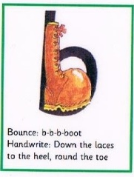 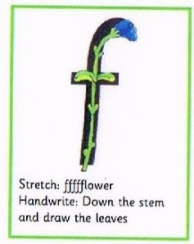 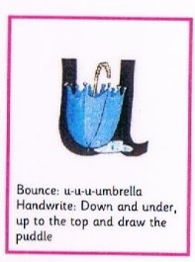

In maths this week we will be looking at mass and capacity. The children will learn the associated language and that objects can be ordered according to their size and properties.

We will continue to learn about Autumn and weather permitting, will venture outside to look at different leaves and habitats.

  

PLEASE read at home as often as possible but at least 3 or 4 times a week**.** C:\Users\ciaramoran\AppData\Local\Microsoft\Windows\Temporary Internet Files\Content.IE5\5JV43MRH\MC900440424[1].wmf

Optional Home Work.

It is always beneficial to read with your child 3 times per week. Please can you ensure that you record reading in your child’s reading record book so that we can monitor how often they are reading.

Try to practise writing this week’s letter sounds. You could practise writing them in the sand, with a stick in mud, with chalks, water etc. Learning through play is really encouraged.

This week we are consolidating our red words at school and will not be adding new red words.

If anyone else is collecting your child, please let us know in the morning.

Star Celebrations: Leighton for being a concentrating crocodile.

               

**Reminders:**

Please can we ask, that after half term, the children come to school dressed in their PE kit on a Tuesday. In order for them to keep warm we recommend that jogging bottoms and school jumpers are considered. The children will stay in their PE kit all day.

In support of Harvest we are going to collect any canned foods or toiletries that you would be willing to donate. These will be donated to the Liskeard Food Bank. If you would like to contribute, please donate what you can by Tuesday 20th October by allowing your child to bring it in to school and we will arrange for it to be delivered to the Food Bank. Many thanks in advance.

Diary dates

School closes on Friday 23rd October at 12.30.

School returns Tuesday 3rd November.

School closes Friday 18th December for Christmas.

After half term the Friday closure, will remain in place for now but will be reviewed regularly in line with national guidance and local advice.