Reception Newsletter

Monday 19th October 2020

Learning

This week we will be learning to sound, write and spell with the letter sounds e, l and h.

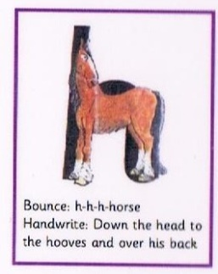 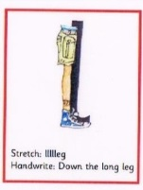 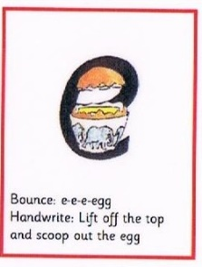

In maths this week we will be looking at 1 more or 1 less than a given number and 2d shape names and properties.

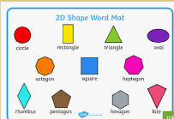 **The children have been learning to become story tellers, and they are very excited to tell you their story. Due to Covid Restriction, we have made the decision to video this and we will send it via Tapestry on Friday. The children do have letter formation books and if you wish to see them or speak to a member of staff about your child’s progress, please feel free to make an appointment with a member of staff.**

**irr**

Optional Home Work.

We hope that you all enjoy the half term. The children really do deserve the break.

It is always beneficial to read with your child 3 times per week. Please can you ensure that you record reading in your child’s reading record book so that we can monitor how often they are reading.

The letter sounds that we have learned so far are attached under the school blog. Please feel free to go over saying them together.

If anyone else is collecting your child, please let us know in the morning.

  

**Reminders:**

**Thank you for all the Harvest donations, we will make sure that they reach the food bank.**

**Please can we ask, that after half term, the children come to school dressed in their PE kit on a Tuesday. In order for them to keep warm, we recommend that jogging bottoms and school jumpers are considered. The children will stay in their PE kit all day.**

Mr Jones has kindly volunteered to take the children for Wild Tribe sessions next term on a Monday. Please see the letter attached and also posted on the blog.

Star Celebrations: Lotte who is the first child to gain 10 pirate points for her learning skills and behaviour. Well done Lotte, we are very proud of you.

               

Diary dates

School closes on Friday 23rd October at 12.30.

School returns Tuesday 3rd November.

School closes Friday 18th December for Christmas.

**After half term, the Friday closure will remain in place for now but will be reviewed regularly in line with national guidance and local advice.**