Tuesday 24th November 2020

Hi all, thank you to those of you who posted on Tapestry yesterday. I have attached some more home learning ideas on Tapestry. Here is a guide on how you could structure a morning or afternoon with your child which is like what we would do during a typical session.
First thing: We say good morning, sing our days of the week song (https://www.youtube.com/watch?v=oKqAblcwFOA) then we talk about what the weather is like and then sing a nursery rhyme. These can be found on the bbc nursery rhymes website (https://www.bbc.co.uk/teach/school-radio/nursery-rhymes-songs-index/zhwdgwx)

Name recognition: We have been practicing this lots over the last few weeks. This is an important skill for the children to be able to demonstrate. Here are a few fun and creative ideas of how you could do this at home using different resources. It would be great to see photos of you doing this at home.
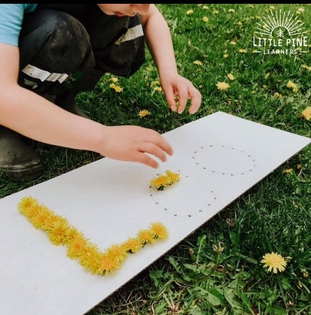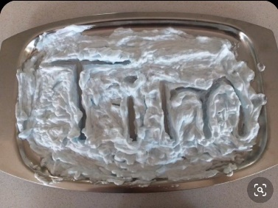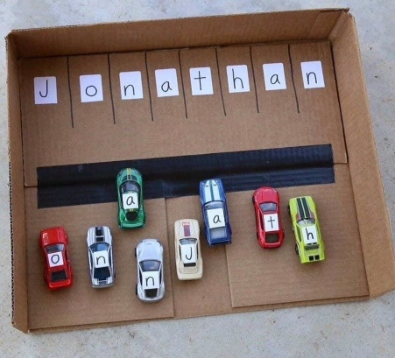

Types of play: Imaginary: This is important for children as it helps to develop their language, social skills and ability to use their imagination. This could be done through acting out stories, role play such as kitchen, babies or animals.
Fine motor skills: We do lots of fine motor practice in pre-school. It’s very important to strengthen the children’s muscles in their hands. This can be done in many ways:
Play dough
Scissor skills practice
Threading beads
Puzzles
Lego/block play

We usually have a morning snack of fruit and milk and then continue with learning through play.
After lunch we usually take part in cosmic kids yoga from YouTube. This starts the afternoon off in a calm way and is good for the children to do as it helps them stretch as well as follow instructions. (https://www.youtube.com/watch?v=nRkojdFPjjI) Only do a small amount of this as it is quite long! (find a different theme of yoga if you would like to).
Maths: This week we are focusing on counting from 6-10 and recognising these numbers too. If you have them at home hide them in different places and see if the children can recognise them and in random order too. Can they use their fingers to represent the numbers?

Enjoy my story that is above. I will be recording a new one this week!
Thank you, Miss Ronald

