Home learning – Wednesday 6th January 2021
Phonics
Read Write Inc have a daily phonic lesson for you to join in with. The link for you to access the phonic lessons is: Ruth Miskin Training - YouTube
Each day you will have a schedule to follow- which will show you what video/lesson to watch.
The following tells you what colour group you are in and which set of sounds that corresponds to.
Red group –set 1 sounds
Purple, pink, or orange group- Set 2 sounds
Yellow, blue, or grey group- Set 3 sounds
The schedule for today is:
Wednesday 6th January
Set 1 - a ( a , a, a ant )
Set 2 – ee ( ee what can you see)
Set 3 – oi ( oi spoil the boy)
Reading longer words – oy/ oi
Look for your sound of the day on the schedule then click the link above- once you are on you tube you can watch and do the speed sounds video first as a warm up (as we do in class) then choose the video with your sound of the day and follow.
If you are a free reader please revisit set 3 sounds and videos and also take the opportunity to read some of your book at home- you could then do a book review, design a new front cover, rewrite parts of the story and draw and write a comic strip about your book (choose one a day).
You can also access phonics play - PhonicsPlay
Here you can click on resources and there are three games that you can access for free (dragons, pirates and aliens) can you choose yur sound of the day and then complete the game?
English
We are starting our new genre this week – Letters.
What do you know about letters already? Before we start our journey and learn about the features of letters, can you write a letter to Father Christmas to say thank you for visiting you, with any knowledge that you know already. Think about how you may start a letter? What might you include? Why are you writing the letter? How do you end a letter?
We are doing this ‘cold write’ so you can compare and assess your progress at the end of the genre.
Before you move on you can listen to this story that we will be following a little in english these next couple of weeks; The Day the crayons quit - Books Alive! Read Aloud book for children - Bing video
Spellings
Year 2 spellings this week
cry, fly, dry, try, reply, sly, shy, terrify, sky, multiply
Maths
For the next couple of weeks we are going to be focusing on division. To start off with we are going to be thinking of it as sharing out.
e.g. 8 ÷ 2 is thinking about 8 shared out by 2. Have a look at the question below. You can either print it out or draw your own muffins and plates and share them out equally between the two plates.
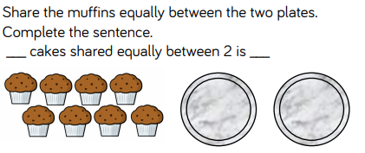
Have a look at both PowerPoint 1 and 2. Work through the questions, then have a go at this:
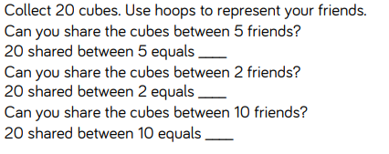
You will need 20 small objects, this could be pasta, counters, small figures etc. anything that you have at home that will work.
You then might want to draw some circles on paper to then share the items out depending on how many by.
Extension – Can you write the three linking division number sentences for the questions.
Answers (just in case you want them): 4, 10,2.
Learning Adventure
ur new question: How does colour influence our world?
What does the word Influence mean? What does world mean?
Tell your adults at home what you think they mean.
following on from your understanding of the question – what do you think you would like to learn this half term? WE would like to do some music, art, design and technology, cooking and drama. With this in mind what do YOU want to know and learn about?
Can you think of things you would like to do? Can you tell your adult at home. We are going to concentrate on music this week
Once you have thought of some things you would like to learn in these genres can you write some statements/questions that you may have, down on a piece pf paper (I have attached the template if you have a printer at home).
Some question ideas to get you thinking:
Music- how does music make us feel? Does music influence our feelings? Can we move our bodies to music?
Art- How do we mix colours? Why do we have colour in the world? How do we see colour? Can we create our portraits in different colours?
DT- What would the world look like if we saw multi colours all the time? What would the world be like without colour?
DT (food) - Does colour influence our food choices?
Drama- Is colour and drama connected? Can we act out a play including colour?

Remember to read every day, even if it’s a comic or online story. if you can and get lots of exercise –On Friday we will have a ‘Fit Friday’ activity for you to complete also.
Have a lovely day,
Miss Adams and Miss Hughes

