Monday 11th January 2021

Phonics

You will need a pencil and paper today.

We are learning how to say, write and spell with the ar sound.

Today we will be learning the ar sound (look at a book) Different from yesterday’s special friend sound. I have made a video of the lesson which the children can join in with at home. https://youtu.be/SCE0H6XG9ww

Write the ar sounds
Spell each word 3 times –. Car, part, star.
Spell oo sounds 3 times- foot, wool, book with Fred Talk
You could also write the sentence: The sun is a star.

Red words can you write all 3 times and you 3 times. We will come back to these red words tomorrow.

Go through the red words in your bag and learn 3 of the red words that you do not know. If you need more red words, please let us know.

Physical
https://youtu.be/YC_V8hnU2PY here is a spider man work out
or you could go outside and time yourself for a 10 minute run.
Lunch time

Maths –
Today at 9.00am BBC bite size are covering maths and 3d shape

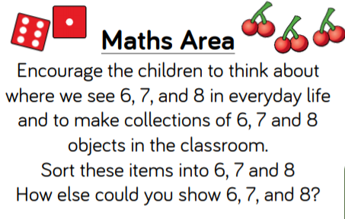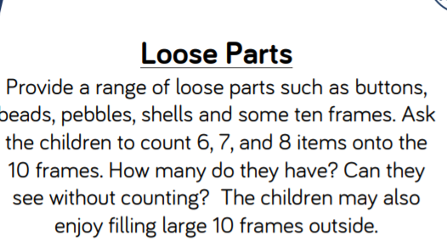
Ten frame down loaded onto the blog, but you can use egg cartons or quickly draw one,

1.) Practise writing your name it should be written in lower case with only the initial sound being a capital letter. Only do this if you need to. Only continue with this if you need too.

Please try to read today (I can provide Ditty sheets, if you need more, let me know Via Tapestry.)
I have put the list of red words on the blog page today.
Topic
There is a story on the Blog Page for the children to listen too. Can you draw a picture of the Solar System and label the planets?

