Tuesday 12th January 2021

Phonics

You will need a pencil and paper today.

We are learning how to say, write and spell with the or sound.

Today we will be learning the or sound (look at a book) Different from yesterday’s special friend sound. I have made a video of the lesson which the children can join in with at home.

Write the or sounds
Spell each word 3 times –. Sort, worn, fork.
Spell ar sounds 3 times- smart, spark, park with Fred Talk
You could also write the sentence: The pig did a snort.

Red words can you write all 3 times and you 3 times. We will come back to these red words tomorrow.

Go through the red words in your bag and learn 3 of the red words that you do not know. If you need more red words, please see the blog page (Monday 11th January).

Practise writing your name it should be written in lower case with only the initial sound being a capital letter. Only do this if you need to.

Please try to read today (I can provide Ditty sheets, if you need more, let me know Via Tapestry.)
Story Link : https://www.youtube.com/watch?v=9no8cZFV3GU

Physical
https://www.youtube.com/watch?v=oc4QS2USKmk&feature=youtu.be
or if you prefer to go outside
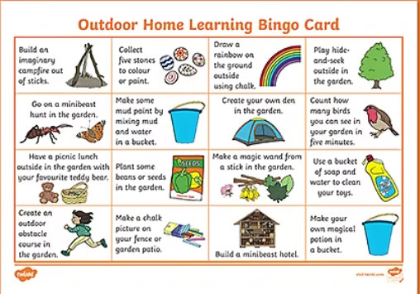
Lunch time

Maths –

We have previously been working hard to recognise coins and to make and count different amounts.
Now I'd like you to have a go at subtracting with money.
I have 10p to spend at the supermarket.
Look at the number sentences below to work out how much change I will get if I pay for the items in my basket.
You could use real 1p coins or your coloured cubes to help you when taking away.

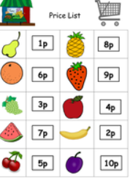

I'm going to buy an apple. I'm going to buy some watermelon.
10p - 4p = 10p - 7p =
I'm going to buy a plum. I'm going to buy a banana.
10p - 10p = 10p - 2p =

Topic
https://www.youtube.com/watch?v=1yBwWLunlOM
Can you design and create your own space rocket?
I have put one on the blog in case you find this easier.

