Wednesday 13th January 2021

Phonics

You will need a pencil and paper today.

We are learning how to say, write and spell with the or, ay sounds.

Today we will be revisiting set 1 sounds and the sounds in set 2 sounds. I have made a video of the lesson which the children can join in with at home. Please can you revisit any sounds you are not confident on. This is also a good chance to look at letter formation, size and pencil pressure

There are also some extra practise session on ar and or below. Today can be used as an opportunity to look at pencil grip, letter formation, size and pencil pressure.

I have attached worksheets on the blog for today (ay and or).

https://youtu.be/zKLYNjkR0BI - ar sound

https://www.youtube.com/watch?v=0TKWxjU0UgQ or sound

Red words can you write all 3 times and you 3 times.

Go through the red words in your bag and learn 3 of the red words that you do not know. If you need more red words, please see the blog page (Monday 11th January).

Practise writing your name it should be written in lower case with only the initial sound being a capital letter. Only do this if you need to.

Please try to read today (I can provide Ditty sheets, if you need more, let me know Via Tapestry.)
Story: https://www.youtube.com/watch?v=H6S7RyE80QI
How to catch a star.

Physical
https://www.youtube.com/watch?v=tSi2ix1i180 Jo Wicks you can go directly to his site for a more up to date version.
or if you prefer to go outside you can choose an activity below or go for a walk/run/bike ride
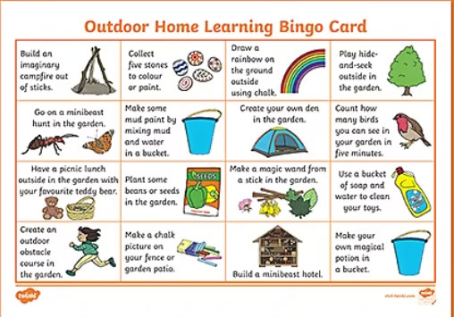
Lunch time

Maths –

We are still focusing on money today please follow the link to a money lesson. Today we will be recognising the value of 1p and recognising other coins. Please use the link below.
https://classroom.thenational.academy/lessons/recognising-the-value-of-one-penny-and-the-values-of-other-coins-cnj62r

Topic
Still looking at the solar system and earth- today can you find out 3 interesting facts about the earth. You could even draw the earth and then write your facts.
https://www.youtube.com/watch?v=JGXi_9A__Vc
if you want to do more on the solar system use the link below, this also has today’s story in it.
https://classroom.thenational.academy/lessons/to-understand-some-features-of-our-solar-system-cruk0c?activity=video&step=1

