Thursday 14th January 2021

Please remember that learning through play is just as valuable as lesson time. Periods of time are encouraged to be set aside for the children to enjoy learning through play and their choice.

Here is a ‘Be responsible’ assembly to share.
https://youtu.be/UNuy25Eq8wg

Phonics

You will need a pencil and paper today.

We are learning how to say, write and spell with the air sound.

I have tried to differ this lesson slightly by providing a work book on the blog. But if you prefer you can spell : air, chair, fair 3 times.
If you are a go for it Gorilla, you could write the sentence: The chair was low.

Go through the red words in your bag and learn 3 of the red words that you do not know. If you need more red words, please see the blog page (Monday 11th January).

Practise writing your name it should be written in lower case with only the initial sound being a capital letter. Only do this if you need to.

Please try to read today (I can provide Ditty sheets, if you need more, let me know Via Tapestry.)

Physical
https://youtu.be/0T5w6CdyceM I thought it might be nice to see a familiar face (Mr Jones is taking this work out.)
If you prefer to go outside, you can choose an activity below or go for a walk/run/bike ride
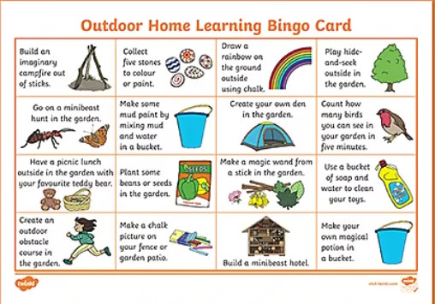

Lunch time

Maths
In this lesson, we will be exploring different combinations of coins to give a total amount up to 10p using a ten and five frame.

https://classroom.thenational.academy/lessons/exploring-different-combinations-of-coins-for-a-given-total-of-up-to-10p-60v64d?activity=video&step=1

you will need a 10 frame and some coins.

If you are interested in maths and counting in French at 9.30 this morning BBC Bite size are offering a lesson in this.

Story -I want to be an astronaut
https://www.youtube.com/watch?v=LvqaZrcWXUk
Topic
Astronauts.
Please see power point attached on the blog.

We have made our rockets and the moon, so it only seems right to have an astronaut. Hand out on the blog for this or you could create your own
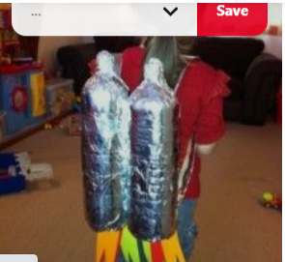

Child’s choice.
Last year we took our children to meet the mermaid at the NMA . If you are interested in listening to Marina the mermaid she is offering a lesson at 1.30-1.45 on Friday.
https://www.national-aquarium.co.uk/learning-at-the-aquarium/home-learning-sessions/

