Friday 15th January 2021

Well done everyone this is the last day of week 2 of home learning and you all never fail to amaze me with your efforts.
Please remember that learning through play is just as valuable as lesson time. Periods of time are encouraged to be set aside for the children to enjoy learning through play and their choice. Also try not to put too much pressure on yourselves, learning is everywhere.

Phonics
In phonics today we are going to hold a sentence today.
The car had a bump.
Video link:
https://youtu.be/CWzcj-SwMAs

Some useful sites for phonics activities below:
https://www.phonicsplay.co.uk/resources/phase/2/picnic-on-pluto- spelling

https://www.bbc.co.uk/bitesize/topics/zf2yf4j/articles/zdrd8xs - red words

Physical Fun Fit Friday
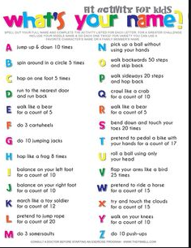

If you prefer to go outside, you can choose an activity below or go for a walk/run/bike ride
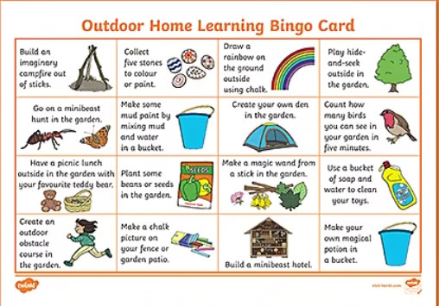

Lunch time

Maths

In this lesson, we will be exploring giving change from ten pence using a ten frame. Coins and a ten frame are on the blog if required .
https://classroom.thenational.academy/lessons/exploring-giving-change-from-ten-pence-c4tkcc

Child’s choice.
Last year we took our children to meet the mermaid at the NMA to meet the mermaid. If you are interested in listening to Marina the mermaid she is offering a lesson at 1.30-1.45 on Friday.
https://www.national-aquarium.co.uk/learning-at-the-aquarium/home-learning-sessions/

Friday pomp om treat
Movie lasts for 20 minutes. Crong and the star:
https://www.youtube.com/watch?v=ngiIQLHrCDQ

Topic
Constellations
https://www.youtube.com/watch?v=adKrNga8-Qs
I have added a hand out on making your own constellations on the blog. Perhaps you could use cotton buds/ playdough and straws/ sticks and tape to adapt the resources to make this viable for you.

