Monday 18th January 2021

Please remember that learning through play is just as valuable as lesson time. Periods of time are encouraged to be set aside for the children to enjoy learning through play and their choice. Also try not to put too much pressure on yourselves, learning is everywhere.

Phonics
In phonics today we are going to learn to read write and spell with the sound ir (whirl and twirl).
Spellings
Ir- girl, bird, dirt
Air- hair, chair, stair

If you want to write a sentence.
The bird was sat in the tree.

New red-words are and her.

Set 2 sound mat is on the blog to help identify sounds.

Video link:

Some useful sites for phonics activities below:
https://www.phonicsplay.co.uk/resources/phase/2/picnic-on-pluto- spelling

https://www.bbc.co.uk/bitesize/topics/zf2yf4j/articles/zdrd8xs - red words

https://www.bbc.co.uk/iplayer/episode/p0872x41/alphablocks-magic-words-1-meet-alphablock-a

Physical

Jo wicks today
https://www.youtube.com/watch?v=fAUckPMJKSY

Or go outside and make your own obstacle course and then time yourself to see how long it takes you to complete your obstacle course.

Lunch time

Maths
This week we will be starting to look at time.
Please can the children order the months of the year and then start to think about the seasons of the year. You could make this into a game by hiding the months around the house.
Which months are in which season? What special event takes place in January / February etc...
Please see the hand out and power point on the blog to help with this.
A season sorting activity:
https://www.education.com/game/seasons-suitcase-sort/

Story
Our story also links in with time. The children should all be confident with the days of the week. Ask questions such as what day is it going to be next/ tomorrow/ what day was it yesterday etc...
https://www.youtube.com/watch?v=eCBFMH2pQe8

Topic
There is lots going on in space with CBeebies this week. Please see below for this week’s timetable.
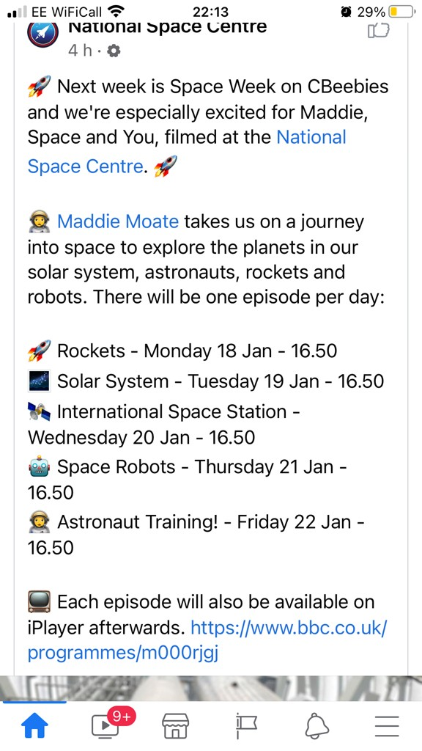

Child’s choice.
As an optional extra and providing you have the resources you could make a space helmet.
https://www.bbc.co.uk/cbeebies/makes/presenters-space-helmet-make?collection=space-week
OR
Listening skills
https://www.bbc.co.uk/teach/bring-the-noise/eyfs-music-sonic-explorers-supermarket-space-station/zmsqcqt
