Wednesday 20th January 2021

Please remember that learning through play is just as valuable as lesson time. Periods of time are encouraged to be set aside for the children to enjoy learning through play and their choice. Also try not to put too much pressure on yourselves, learning is everywhere.

Phonics
Please keep going with set 1 sounds if you need to.

Today we are learning to read, write and spell with oy sound (toy for a boy).
I have tried to make this a little different again and have added some oy worksheets.
Phonics lesson link: https://youtu.be/E-qb5X2kSUw

Some useful sites for phonics activities below:
https://www.phonicsplay.co.uk/resources/phase/2/picnic-on-pluto- spelling

https://www.bbc.co.uk/bitesize/topics/zf2yf4j/articles/zdrd8xs - red words

https://www.bbc.co.uk/iplayer/episode/p0872x41/alphablocks-magic-words-1-meet-alphablock-a

Physical/ mindfulness
https://www.youtube.com/watch?v=mV9BBR1RoGg

Outside physical
Why not time yourself on a walk today or you could time yourself doing laps of the garden, jumps, how many can you do in a minute?

Maths

Please watch the short video. today we will be learning about the hands on a clock and reading o’clock times.
https://www.youtube.com/watch?v=V32tRiEQ2AA
time hand out on the blog to complete if needed or you could draw your own clocks.
Mathletic’s is also available.

Our story today is not linked to space and is called ZOG
https://youtu.be/WW8Mdne5Xuk
I have added a review sheet today so you can write about what you liked about zog and the story.
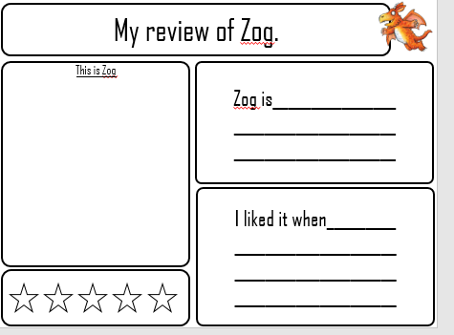
Topic
Cbeebies are showing International Space Station today at 4.50
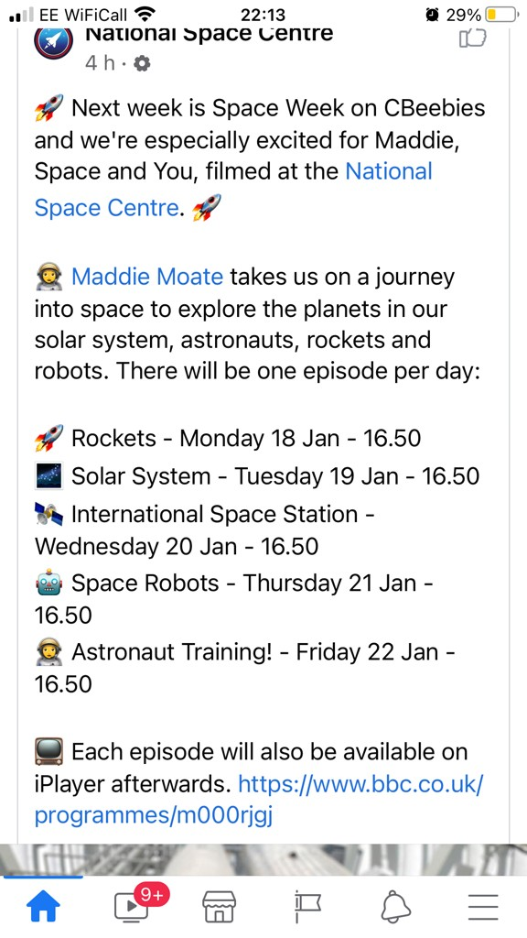

Science Experiment
You will need a balloon
