Thursday 21st January 2021

Please remember that learning through play is just as valuable as lesson time. Periods of time are encouraged to be set aside for the children to enjoy learning through play and their choice. Also try not to put too much pressure on yourselves, learning is everywhere.

Assembly

https://www.stcleerprimary.co.uk/Blog/Heads-Blog

Phonics

I am hoping the children are able to all write their first name by now. If not can you, please keep going with this.

Today we are going to concentrate on our handwriting I will model the formation of some of the letters and add a writing mat (this has the letter formation rhymes on) to the blog.

Can we go through the set 1 sounds and pay extra attention to the a, b. d, g, p, w, k. (Thank you)? The pencil grip we encourage is frog on a log 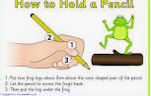
We are looking at letter size, position, pencil pressure and letter formation.

A useful site for letter formation
https://www.doorwayonline.org.uk/activities/letterformation/

Physical
Mr Jones and his lucky dip

https://www.youtube.com/watch?v=4gK2_xTtDXo&feature=share

Outside physical

Why don’t you go and play your own lucky dip outside? You could use your football, tennis bat and ball, climbing frame, space hopper, swing etc.

Story
Robot Rumpus
https://www.youtube.com/watch?v=FtvjA7lrW84

Maths
Looking at a clock
https://www.youtube.com/watch?v=HrxZWNu72WI

A minute, second and hour song
https://www.youtube.com/watch?app=desktop&v=gEStq1e1Qrc&fulldescription=1&hl=en&gl=US&client=mv-google

design your own watch (hand out on the blog.

Topic
Cbeebies are showing space Robots today at 4.50
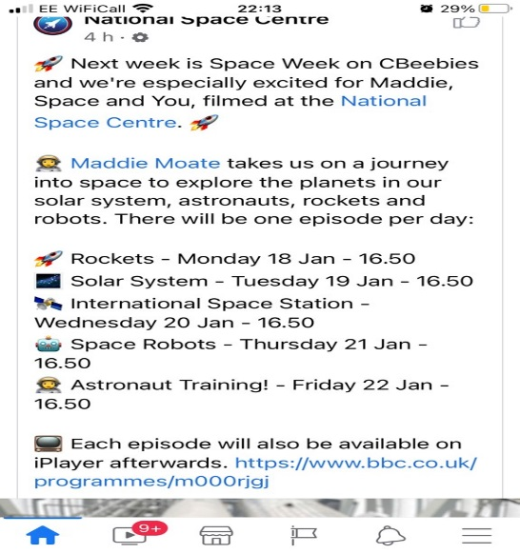

Creative
Using the recycling bin and junk around the house can you make your own robot?

