Music

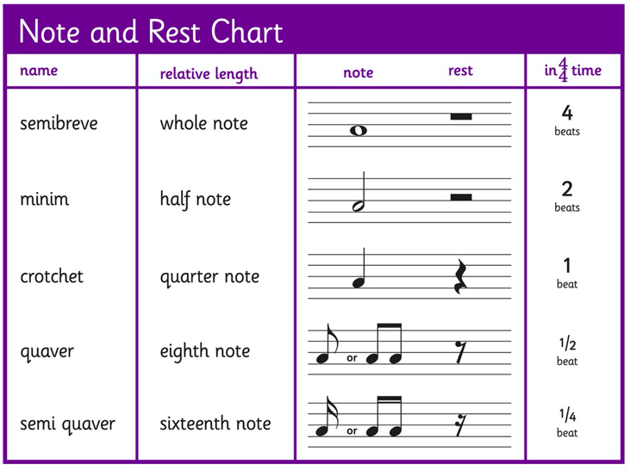

Use the sheet below to make a simple tune of 8 beats or more. You can use shapes or musical notations. There are some musical notations above if you want to use these.

