Guided Reading
Monday 25th January 2021
Join Mrs Nute for a live guided reading lesson at 9.30. We will read the first 2 pages of the Lion, The Witch and the Wardrobe by C.S Lewis. We will discuss the questions in today’s assignment, focusing on new vocabulary and inference. Can you re-read this text and answer the questions below?
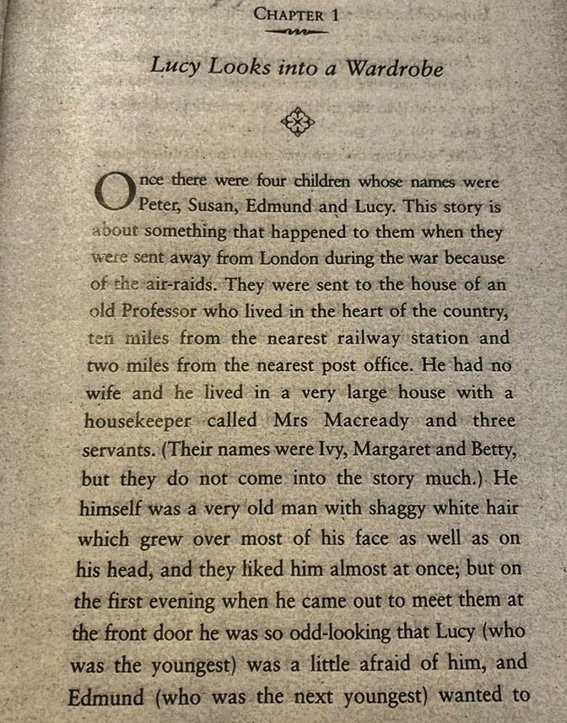
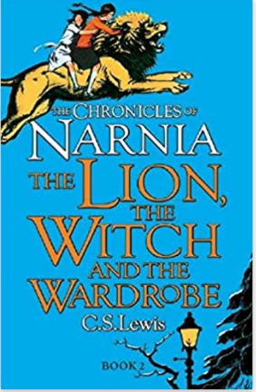

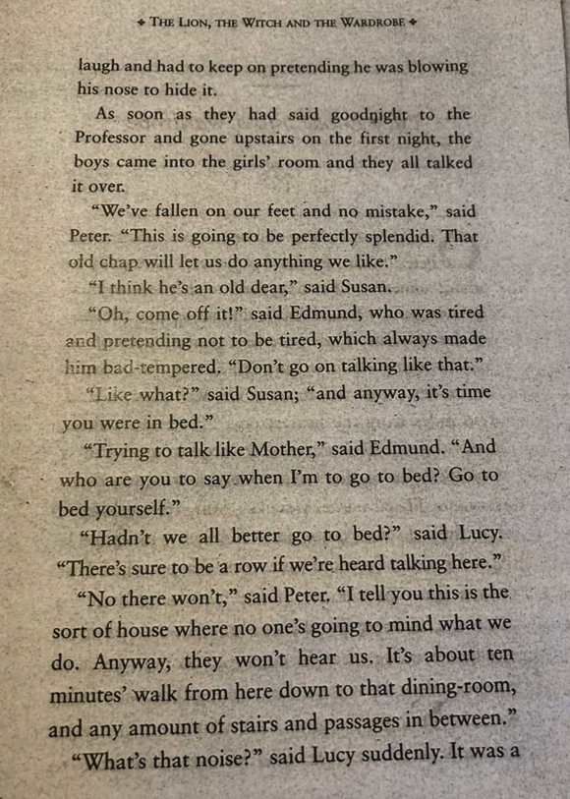

We are learning to apply our inference skills

1. Can you write the definition for the idiom or word? (Vocabulary)

fallen on our feet
splendid
air-raids

2. Based on evidence from the text, why do you think the children were sent to live in a new house?

3. How do you think Peter is feeling about living in the new house? Give evidence from the text to support your answer.

4. Can you describe the character of Lucy and how she is feeling? How does she differ from Peter? Make sure that you reference the text.

5. What are your first impressions of the Professor?

