Chilli Challenges – Year 4

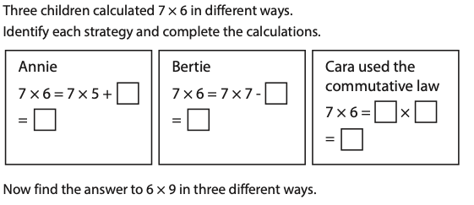

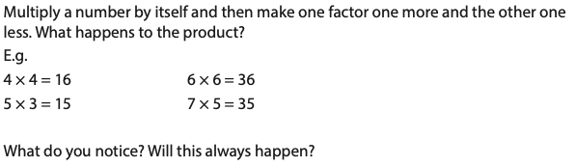

The total weight of 5 watermelons and 3 pineapples is 31kg. Each watermelon weighs 3kg more than each pineapple. Find the total weight of 4 watermelons.

