FOREST SCHOOL ASSIGNMENT Monday 25th January 2021
Making Narnia Ice Decorations
Look at the task below.
Please ask an adult to help you with this.
If you are able to, draw a picture of your sculpture (and write a couple of sentences to tell us how you got on) in the box and send it back to us.
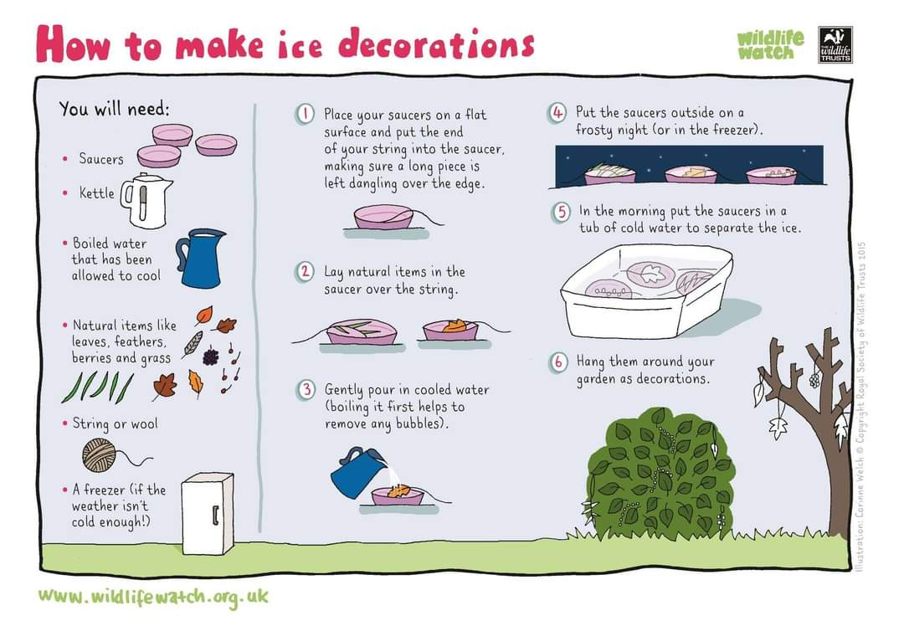
Diagram of my sculpture | How did I get on?  What did I learn?

