Friday 22nd January 2021

Please remember that learning through play is just as valuable as lesson time. Periods of time are encouraged to be set aside for the children to enjoy learning through play and their choice. Also try not to put too much pressure on yourselves, learning is everywhere.

You can download lots of eBooks from Oxford Owl. The link is below

https://www.oxfordowl.co.uk/for-home/find-a-book/library-page/

Phonics

I am hoping the children are able to all write their first name by now. If not can you, please keep going with this.

Story
Aliens Love Underpants.
https://www.youtube.com/watch?v=HWbSrmuyptw

Today for phonics you will need to listen to the story carefully. You may also want a few of your red words to hand and the set 1 sound mat.
I have attached a writing frame (there are 4 on there so the children can choose which one they would like). Can the children write a sentence about the Aliens for example: Dear Aliens, please do not steal my underpants I need them?

We are interested in the children using their phonics skills and are not expecting the correct spelling of all the words, especially as we have not learned all the sounds yet ie: ie or er.

A useful site for letter formation
https://www.doorwayonline.org.uk/activities/letterformation/

Feel Fit Friday
https://www.youtube.com/watch?v=L_A_HjHZxfI

Reading
Today we have a challenge!! Can you Record a video of you reading a ditty and post it on Tapestry?

Topic
Cbeebies are showing astronaut training at 4.50 today
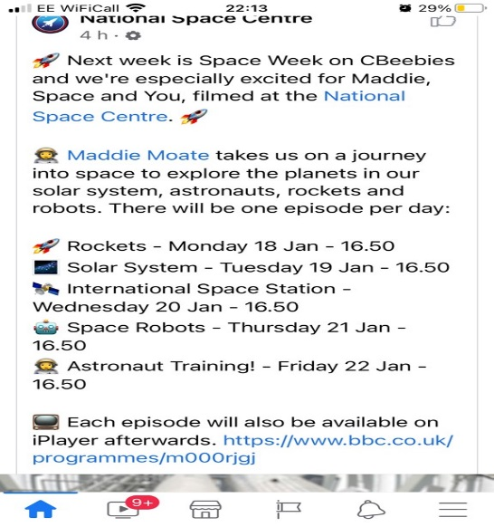
Maths today
Handouts are on the blog page.
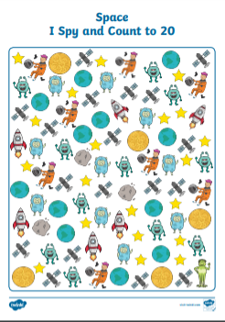

Optional craft
